Documentation of

Aspen plus-Python interface

Python library for automating the Aspen Flowsheet, Blackbox solution to input, run, and receive data from Aspen.

 

Receive results

Input design choices

Table of Contents

1. Introduction: 6

1.1. How to use the documentation 6

1.2. File Formats in Aspen Plus 7

1.3. Variable manager 8

1.4. Etymology of function names: 10

2. Common use cases: 12

2.1. Tutorial: Learn to connect, run, get reports, set variables, 12

2.2. Case 1.1: Single variable varying: 15

2.3. Case 1.2. Double variable varying 16

2.4. Scipy Optimization library: 18

2.4.1. Case 2.1. Genetic algorithm 19

2.4.2. Case 2.2. Brute force algorithm: 20

2.5. Future improvements to library: 22

3. Power functions 23

3.1. Flow sheeting, Placing, Removing 24

3.2. Running Simulations: 24

3.3. Saving Reports, Exporting Files: 25

4. Higher level functions: 25

5. RADFRAC Inputs 27

5.1. Configuration: Page 1 27

5.2. Streams Page 2 28

5.3. Pressures Page 3 29

5.4. Condenser Page 4 31

5.5. Reboiler Page 5 33

6. RADFRAC OUTPUTS 34

6.1. Summary: Page 1 Output 34

6.2. Balance: Page 2 Output 35

6.3. Split fractions: Page 3 Output 36

6.4. Reboiler: Page 4 Output 36

6.5. Utilities: Page 5 Output MISSING 38

6.6. Stage Utilities: Page 6 Output MISSING 39

6.7. Status: Page 7 Output 39

7. Heater Input 40

7.1. Specifications: Input Page 1 40

7.2. Flash Options Input Page 2: 41

8. Heater Output Missing 42

8.1. Summary Page 1 42

8.2. Balance Page 2 42

8.3. Phase equilibrium Page 3 43

8.4. Utilities Page 4 44

8.5. Status Page 5 44

9. RPLUG Input 45

9.1. Reactor type Input Page 1: 45

9.2. General Reactor Configurations Input Page 2: 49

9.3. Streams: Input Page 3: 50

9.4. Reactions: Input Page 4: 50

9.5. Pressure specification Input Page 5: 51

9.6. Reactor holdup Input Page 6: 52

9.7. Catalysts Input Page 7: 53

10. RPLUG OUTPUT 54

10.1. Summary: Page 1 54

10.2. Balance: Page 2 55

10.3. Distribution: Page 3 MISSING 56

10.4. Polymer Attributes: Page 4 MISSING 56

10.5. Status: Page 5 56

11. RCSTR Inputs 57

11.1. Specifications Input Page 1: 57

11.2. Streams Page 2: 59

11.3. Kinetics Page 3: 60

11.4. Particle Size Determination PSD Page 4: 61

11.5. Component Attributes Page 5 missing 62

11.6. Utilities Page 6: missing 62

11.7. Catalyst Page 7: 62

12. RCSTR Output: 63

12.1. Summary Page 1: 63

12.2. Balance Page 2: 64

12.3. Reaction Kinetics Page 3: missing 65

12.4. Component Generation Rates Page 4: missing 65

12.5. Custom Reaction Variables Page 5: Missing 65

12.6. Utility Usage Page 6: Missing 65

12.7. Distributions Page 7: Missing 66

12.8. Polymer Attributes Page 8: Missing 66

12.9. Crystallization Page 9: Missing 66

12.10. Status Page 10: 66

13. Mixer Input 66

13.1. Flash Option Page 1: 66

14. MIXER Output 67

14.1. Summary Page 1: 67

14.2. Balance Page 2: 68

14.3. Status Page 3: 69

15. RYIELD Input 70

15.1. Specifications Page 1 70

15.2. Streams Page 2: 71

15.3. Yield Page 3: 71

15.4. Flash Options Page 4: 73

15.5. Particle Size Determination PSD Page 5: 73

15.6. Component Attribute Page 6 74

15.7. Component mapping Page 7 74

16. RYIELD Output: 75

16.1. Summary Page 1: 75

16.2. Balance Page 2: 75

16.3. Phase Equilibrium Page 3: 76

16.4. Weight distribution Page 4: missing 77

16.5. Pseudocomp Breakdown Page 5: missing 77

16.6. Utility usage Page 6: missing 77

16.7. Status Page 7: 77

17. FLASH2 Input 78

17.1. Specifications Page 1: 78

17.2. Flash Option Page 2: 79

17.3. Entrainment Page 3: 80

17.4. Particle Size Determination (PSD) Page 4: 80

17.5. Utilities Page 5: 81

18. FLASH2 Output: 82

18.1. Summary PAGE 1 82

18.2. Balance PAGE 2: 82

18.3. Phase Equilibrium PAGE 3: 83

18.4. Utility Usage PAGE 4: MISSING 84

18.5. Status PAGE 5: 84

19. DSTWU Input 85

19.1. Specification PAGE 1: 85

19.2. Calculation Options PAGE 2: 86

19.3. Convergence PAGE 3: 87

20. DSTWU OUTPUTS: 88

20.1. Summary PAGE 1: 88

20.2. Balance PAGE 2: 89

20.3. Reflux ratio profile PAGE 3: 90

21.4. Status PAGE 4: 91

21. FSPLITTER Input 91

21.1. Specification PAGE 1: 91

21.2. Flash Options PAGE 2: 92

21.3. Key Components PAGE 3 92

22. FSPLITTER Output 93

22.1. Summary PAGE 1: 93

22.2. Balances PAGE 2: 93

22.3. Status PAGE 3: 94

19. STREAM INPUT 95

19.1. Specifications PAGE 1 95

19.2. CI Solid PAGE 2 MISSING 96

19.3. NC Solid PAGE 3 MISSIGN 96

19.4. Flash Options PAGE 4 97

19.5. EO Options PAGE 5 97

19.6. Costing PAGE 6 99

20. STREAM OUTPUTS: 100

# Introduction:

The following report represents the documentation for a Python library that has been created to automate Aspen Plus from an interactive user input, toward a fully automated black box solution. The Python library has functions for setting the inputs and retrieving the outputs of the most important process equipment’s, as well as creating/altering the flowsheet. Using this, most capabilities of the Aspen plus user interface are transferred into python. It is possible to control aspen without ever opening it and setting manual inputs in aspen. This is of course still incomplete since Aspen Plus is a very extensive program.

**Motivation:**

The initial motivation for generating this library was the usage of Reinforcement learning techniques in chemical engineering to solve problems such as: the sequencing of distillation columns. This was done in a Bachelor thesis upon which this is based [(Bachelorthesis).](https://github.com/YouMayCallMeJesus/ReinforcementlearningWithDestillationColumns/blob/main/Notes%20for%20the%20Bachelor%20assignment%2027%20long.docx) This proof of concept was successful in implementing the system but since it was the first python code there were considerable problems with both the AI as well as the Aspen Python API side of the thesis. For further development, it was decided that they are to be split apart into separate projects. For more details about the development of the Artificial intelligence side of it please read: [(Migleys AI environment).](https://github.com/lollcat/Aspen-RL)

While creating the Aspen Python interface (API) it was discovered that there is a multitude of other applications where it would be advantageous to make use of automated optimization. Examples of this are: placing new blocks, optimizing the entire flowsheet with newer optimization algorithms, dynamic error handling for convergence errors, complete mapping of a variable space, and much more. For more case examples and practical applications go to chapter 2.

## How to use the documentation

As you can see in the number of pages for this documentation there are too many details in this library, that you most likely do not care about. To minimize your labor, I would advise the following procedure to get started with the library:

1. Go through the tutorial code and documentation and test out the cases

* Helps you connect your Python/Aspen and get a first taste of how it works

1. Read the Power function section for flow sheeting, saving, placing, debugging…

* Foundational functions which are needed for any program to run

1. Read the Input section of the equipment which you want to use
   1. Make choices for how you want to simulate it
   2. Check out the basic build tutorial
2. Read the Output section of your equipment
   1. Decide on what you find important in the Outputs
3. Start running simulations and change some parameters
4. Build your own functions to optimize the process.

* For this check out: Chapter 1.3.

If you have any trouble, email me: Richardxtenxhagen@gmail.com

## File Formats in Aspen Plus

Aspen Plus has many different methods for outputting data to the User. These can be divided into methods that are meant to be read by humans and ones which are to be used by the software. The ones which can be read by humans are extremely useful for debugging and just “seeing” what is happening. On the other hand, if you are trying to connect Aspen into some optimization algorithm you want the data to be in a variable form which you can set and read. This fundamental dualism represents a major problem that can be partially solved using an API or by using some exported files. These are very useful since it allows for the automatic generation of backups and reports for the work.

Here is the listing of the currently supported Aspen Plus files:

.apw: Aspen Plus document

This is an intermediate storage of the flowsheet before you. After loading, it starts exactly where you left off with all the results, runtimes, and everything else you are currently seeing.

.bkp: Backup Files

This is a compact version of apw, it contains all the inputs but no results. Needs to run again to generate the results. It has the advantages of being smaller file size, portable, version independent, can be imported as a section into other sheets, and is thereby more useful when you mean to load some part of the program. Can be read by a human (as a txt but it is painful)

.apt: template file

Default settings for some part of your flowsheet can be used for: units, property sets, stream report formats, and property option sets.

.inp: Input files

A compact summary which can be read out as a text file, is used for standalone Aspen Plus engine runs. Is the File which Aspen uses for input but at the same time it also represents readable documentation for the human. Seems to be an “old school method” of setting the inputs before there was the interactive Aspen Plus GUI. This can be edited automatically and with some string editing skills,s this can also be used to edit the inputs. The format of the txt file is made for the human eye and can be read like a report.

.rep: Report File:

These are reports on specific Simulation results. They can be used as documentation as they are readable as text files. They represent the Ideal method of receiving output data from the Aspen system. It is also possible to generate your own templates for reports if you want to monitor something special.

.sum: Summary Files:

These are summaries of all data inside of the interface. The format is ASCII files. This is the method that other Programs can use to import the results of your simulation into them. They can also be loaded back into the Aspen Plus User Interface.

.cpm: Run Messages Files:

These Files include the Error Warnings and diagnostics for each run. The number of Messages can be controlled with the Setup Specifications Diagnostics sheet. Or on the BlockOptions Diagnostics. If they are not Exported from the Simulation, they are deleted automatically.

.his: History File:

This File contains the Input summary, Errors, warnings, and diagnostic messages from a single run.

These file formats can play an important role in creating, changing, and loading different aspen plus models. It will be possible to export the files for each type and these will be very useful for the making of automatic comparisons of different results of automation

## Variable manager

This entire automation library was made possible by the “Aspen plus ActiveX automation Server” which is detailed in the “Aspen plus User manual V10”. If one wants to edit the library or change things it is advised to read this since it gives an overview of the methods (although the code, there is written in VBA). The basis of it all is the Variable Tree, which can be seen below in Figure 1. It is structured similarly to the Windows File explorer where there are many folders and subfolders. The Variable manager can be found at: Customize/Variable Explorer. Please look at it in your aspen file since this will become your new best friend and you will use it constantly to debug the library.

Figure 1 Variable manager

In the Aspen plus language, each of these points is called a node. Each node has a list of properties that are assigned to it.

Each node can also have a “child” aka a subnode aka a folder in your folder. In this report the dot notation will be used to show the subnode structure: this means that the top node is named first and the subsequent children are then followed by a point. An example of such a path can be seen below which is also used in Figure 1:

Root.Data.BLOCKS.B1.Input.UnitSet

There are far too many variables to go through and figure out what each one of them does. To mitigate this, Aspen has given us the capability to find the variable path by first right-click copying the variable in the interactive interface, and then secondly searching for the path in the variable manager. This allows for the determination of each variable inside of each block. If you increase the size and power of the current library, please send me an email such that I can also include your functions.

Figure 2 Copying variable interactively Figure 3 Finding copied variable path

This process of finding each path has been completed for most of the inputs and outputs of the streams and the following equipment: DSTWU, Flash2, Radfrac, Mixer, Heater, RYield, RPlug, and RCSTR. Finding all these pathways has been the main workload for this project because of the manual labor needed for doing it completely. In the Appendix, there are tables that contain all the different pathways which have been found and the function names which are needed to call them. These variables are not very useful on their own since we are still not able to edit or export them. For this, we make use of the “Win32.com” Python - Windows API for being able to access the Aspen Plus Variables and edit them. With this library imported it is possible to read and edit the Nodes just as if they were files in Windows File Explorer.

Example for the nomenclature of editing or reading the Node Value:

sim.BLK_RADFRAC_Set_CondenserDuty(1000)

**Common Nodes which are used:**

Now that we know how to edit the files, we can look at some of the most used nodes which we have in the python library:

AspenSimulation equivalent to win32.gencache.EnsureDispatch("Apwn.Document")

The top layer of the node system in aspen, it represents the entire aspen program you are currently dealing with. It is used when changing settings or when searching for lower layers.

Interestingly you can make multiple instantiations of this for a single Aspen Plus file at the same time. This allows for the multithreading and running of multiple versions of your code on a single Aspen. In practice, this would be done by calling the instantiations of the “sim” multiple times.

Below this top layer, it is useful to make some artificial node names to simplify the path names of each variable. These can be called as a variable in python and replace the long path string. The two used here are:

STRM equivalent to sim.AspenSimulation.Data.Streams

This node contains the list of all the different “Streamnames” nodes which contain all the data about the specific stream in the flowsheet.

STRM.Streamname.Output Subnode of stream containing the output data

STRM.Streamname.Input Subnode of stream containing the input data

BLK: equivalent to sim.AspenSimulation.Data.Blocks

This node is used as a shortcut to the data which contains all the different process equipment blocks. It contains just like the stream a list of all the equipment and an output and input node which gives the data we seek.

**Node Attributes:**

Each node can have various characteristics which are called Attributes, these are used to describe the point in the network. The most common one is node. The value which contains the numerical value of the node, for example for the reflux ratio: “BLK.Input.RR.Value = 1.5”

The units which are used for the value can be found by using the .Unitrow and .Unitcol attribute. These can be used in combination with the table of units which contains all the possible units. The most common value for both is 0. This also depends on the .Basis which is used for the calculations and it can be either MASS or MOLE.

If the value is not an integer but one of a choice of possibilities then the .Optionlist is useful since it can tell you all possible inputs that are allowed.

## Etymology of function names:

**General Powerfunction**

General power functions are used to interact with the sheet. These range from functions like “Run simulation” and “DeleteAllBlocks” towards “SaveAspen”. These are very useful independent of the exact flow diagram which will be created and they do not follow any special naming convention.

**Notation difference between GET and SET**

When the API interacts with aspen there are two distinct ways of communicating and that is to Get and Set variables. If the function name contains “GET” it will retrieve a value from Aspen and “SET” will define a variable in the flowsheet.

**Block functions:**

The second category is the “Block input functions”. These are always specific to singular process equipments and there are limits on which equipment has been prepared for this. Currently, it is possible to use: DSTWU, Flash2, RADFRAC, Mixer, Splitter, Heater, RYIELD, RPLUG, and RCSTR. In the future, there might be further developments on this to include even more equipment. The Block input functions all start with the Prefix: “BLK_” followed by the name of the equipment for example: “BLK_DSTWU_Set_” and then the Input variable is named. Here is an example:

CondTemp = BLK_RADFRAC_Get_Condenser_Temperature()

As a word of warning: Sometimes a previous input choice (aka an “Option”) enabled the usage of more inputs that were previously not possible. Below is an example of this:

BLK_RADFRAC_Set_PARTIAL_V_L_CondenserOption(“TEMP”)

This means that the CondenserOption is the actual variable that is being set and the variable name contains the dependencies. In this case, a previous choice was made for the Condenser type to be “PARTIAL_V_L” which then enabled the choice of the Condenser Option.

These single variable functions enable the editing of the in/outputs which is useful if repeated simulations are wanted with a few varying parameters. In other cases, it is necessary to make use of higher-level functions which are composites of these lower ones. Examples can be found in the higher functions below:

**Stream input functions:**

The third category is the “Stream input functions” which are very similar to the block functions, but these make use of the STRM block as the first node.

STRM_Set_Temperature(200)

**Higher-level functions (collection of functions):**

Higher-level functions contain a large collection of functions and bundle them together to simplify the process of interacting with Aspen. These functions either intake or output dictionaries which contain all the data, and those can then be printed. They are easily found because their names are in all caps:

STRM_GET_OUTPUTS(“streamname”)

BLK_DSTWU_SET_ALL_INPUTS(dictionary)

Dictionary = BLK_DSTWU_GET_ME_ALL_INPUTS_BACK(“columnname”)

Dictionary = BLK_DSTWU_GET_OUTPUTS(“columnname”)

The complete list of all the higher-level functions can be found in: Chapter 4

The method by which these higher functions have been built is very crude and tends to break since they require custom error handling. This is caused by Aspen having a problem with retrieving the value of the variable which does not exist. As soon as you find this just wrap the part that gives you trouble in a try: … except: Exemption…pass. An example of this can be seen below for DSTWU:

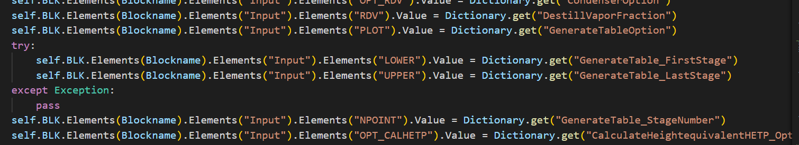

Figure 4 Wrapping higher-level functions in try/except

This will be necessary since the variables which result from options are only created if the option is enabled. In the case of Figure 4, one can see that the GenerateTableOption is NO which means that the GenerateTable_FirstStage does not exist. When we now try to set the variable into this path that does not exist and this results in an error.

# Common use cases:

## Tutorial: Learn to connect, run, get reports, set variables,

The Python file for this tutorial is called TutorialCode.py

The initial tutorial is implemented in Python, and it is used to connect Aspen to Python, determine the directory path, and to go through some of the most important features of this library. This tutorial makes use of printing messages as well as requesting input from the user. These inputs are mainly used to slow down the program and allow the reading of the messages or to look at the flowsheet after alterations were made to it.

Below you can see the figure which shows the Flowsheet:

Figure 5 Flowsheet layout for tutorial

The first step of the tutorial is instantiating the simulation class. This will be used to access the functions from the library. To be able to do this instantiating there are three inputs needed: The name of the Aspen File which will be worked on, the directory where this file can be found, and an option on whether the simulation should also open the Aspen program interactively. Generally speaking, it should be “True” for debugging and “False” when a large number of simulations are to be run since activating the visibility increases runtime.

sim = Simulation(AspenFileName= "Simple Problem.bkp", WorkingDirectoryPath=r"C:\Users\Richard\Desktop\AspenPythonInterface" ,VISIBILITY=True)

The second code block is the usage of a Power function to determine all the different inputs which were used in the already given Aspen tutorial file.

CISTRInputDictionary = sim.BLK_CISTR_GET_ME_ALL_INPUTS_BACK("B1")

RPLUGInputDictionary = sim.BLK_RPLUG_GET_ME_ALL_INPUTS_BACK("B3")

The functions will return a dictionary that contains all the different values with the corresponding names. These will then also be printed such that the user can look at the different options and what had been chosen.

Now that we know what selections were made for these two blocks, it is time to run the simulation. This can be done by either the sim.EngineRun or the sim.Run(), in this case we will make use of the EngineRun since we know that there will be no problems. Usually, it is advisable to use the sim.Run() since it has an internal error handling, which will rerun the simulation in case of aspen simulation errors.

sim.EngineRun()

In the case of the tutorial, one will notice that once the simulation ran a popup message appears in aspen. This dialog box will inform you that the simulation ran successfully and that there were no problems. To suppress further messages from appearing it is possible to make use of the following function:

sim.DialogSuppression(TrueOrFalse= True)

After having run the simulation and finding that it has run successfully it is now time to retrieve the data about the two reactors.

RPLUGOutputDictionary = sim.BLK_RPLUG_GET_OUTPUTS("B3")

RCSTROutputDictionary = sim.BLK_RCSTR_GET_OUTPUTS("B1")

The dictionaries which were found are then also printed which allows for the user to easily comprehend the results.

Afterward the same will also be done for the Productstreams and the result will be printed.

RPLUGStreamDictionary = sim.STRM_GET_OUTPUTS("RPLUGOUT")

These higher-level functions are not used that often since they are less reliable and much slower which means that single-value functions are more common. To demonstrate the functionality of those we will extract the heat duty of the CISTR and then also input a new light key recovery.

HeatDuty = sim.BLK_RCSTR_Get_HeatDuty(Blockname="RCSTR")

sim.BLK_DSTWU_Set_LightkeyRecovery("B1", 0.06)

The lightkey was chosen such that it would not converge since this gives us the chance to discover how convergence errors can be handled.

convergence = sim.Run()

In this case, we will be using the sim.Run() command since it will attempt to run the simulation and once it fails it will try again. In the end, a variable is returned that tells you if there was a convergence or not. This means that you can find out when there was no convergence and deal with it on a higher level.

The next step would be the creation of a new distillation column after the reactor. This means that we will first place the DSTWU:

sim.BlockPlace("B6","DSTWU")

The first variable is the name of the new block and the second one describes the type. All possible types are: "RCSTR", "RPlug", "DSTWU", "Flash2", "Mixer", "Heater", "Radfrac", "Splitter", "RYield"

The next step is the placing of the streams where the Streamtyp can be “MATERIAL”, “HEAT” or “” as well as the connecting of the streams to the block:

sim.StreamPlace(Streamname="S1", Streamtype= "MATERIAL")

sim.StreamConnect(Blockname="B6",Streamname="RPLUGOUT", Portname="F(IN)")

When connecting streams to a block it is necessary to also give a portname that informs the Aspen about the position for the connection. These are predefined and if you want to see all the different ports you need to go to the variable manager.

The next step to get the distillation column to run is to set the input variables. Since I am lazy and it would be boring to go through the list and set each value on their own, we will make use of another higher-level function. In this case, we will first extract the input variables of an already existing column and then put those into the new column.

OldDSTWUinputDictionary = sim.BLK_DSTWU_GET_ME_ALL_INPUTS_BACK("B1")

sim.BLK_DSTWU_SET_ALL_INPUTS("B6", OldDSTWUinputDictionary)

After running the simulation, we now want to export all the results which we have created. For this we will export all the reports we can:

sim.ExportReportFile("TutorialReportFile")

sim.ExportInputFile("TutorialInputFile")

sim.ExportRunMessagesFile("TutorialRunMessageFile")

sim.ExportSummaryFile("TutorialSummaryFile")

sim.ExportInputFileWithGraphics("TutorialInputGraphics")

Since we changed the layout of the flowsheet we would also like to save the file under a new name.

sim.SaveAs("AspenfileAfterTutorial.bkp", True)

## Case 1.1: Single variable varying:

The Python file for this tutorial is called CaseExample1.py

Figure 6 Flowsheet layout

In this case, there is a distillation sequence where the stage numbers are set depending on a list value. Once a value has been set the simulation is run and the output data is found. In this case, the main data points of interest are the Reboiler/Condenser temperature and duty. These are then plotted against the stage numbers but if the convergence was unsuccessful the value was excepted.

This follows a certain pattern that can be used to loop through any characteristic and find the results. For this I will present it as a pseudo-code:

*ListOfInputs = []*

*Loop through ListOfInputs:*

*Set Input*

*Run simulation*

*Get outputs*

*Do some data analysis*

The results for the first case are given below and they show the results in dependence of the number of stages.

Figure 7 Splitfraction of destillation column in bottom stream per stage number

Figure 8 Condenser heat duty depending on number of stages

Figure 9 Reboiler heat duty depending on number of stages

By changing a few lines of code this kind of analysis could be done for any variable in Aspen Plus. It enables you also to make many simulations to find trends and patterns. This could also be used to learn about the impact of design parameters on your overall design.

## Case 1.2. Double variable varying

This case is almost the same as the previous one just that instead of only going through the list of Stage numbers for only the first column you will loop over the columns as well as the stage number list. This is supposed to show how it is possible to make this looping system substantially larger by only adding a few lines of code. If it is planned to do more complex optimizations, it will be necessary to use different methods since the number of possible combinations rises exponentially the more loops are added. To minimize the number of samples needed to find the optimum we will have to use an optimization algorithm.

Figure 10 Condenser temperature for two columns depending on stage number

Figure 11 Splitfractions in bottoms depending on stage number

As you can see, the split fraction in B4 seems to reach diminishing returns for water by around 12 stages. This means that if our goal is to remove the water this would already suffice. In comparison to that, the B3 still increase its split fraction for water even at 20 stages. This can then be used as an indication that even more stages might be necessary. This is a very simple example for this type of looping through lists and it could be even more interesting by doing this split fraction test for differing pressures and other variables.

## Scipy Optimization library:

The Python file for this tutorial is called CaseExample2.py

Figure 12 Flowsheet layout

This optimization makes use of the scipy library which includes a large list of options for algorithms to use. In this case, a genetic algorithm and a brute force method will be applied. For this, it is necessary to supply the scipy library with a function that can be called, that intakes certain variables and which returns an integer value. This integer value will be minimized by repeatedly calling this function with varying input values.

This requires the funcToMin to do the following things:

1. Unpacks the input variables
2. Sets the Input variables into the Aspen Plus flowsheet for both columns
3. Runs the simulation
4. Retrieves outputs and prints them
5. Retrieves values needed for sizing and cost analysis
6. Sizes equipment, Investment cost analysis, revenue, annual profit
7. Return the negative profit

The Inputs which can be given in an array called: “v”. In this case we will take the stage number and the reboiler duty for both columns. This array can be changed into a list that contains any number of inputs which means that it would be easy to add more parameters to the optimization as long as the funcToMin still runs.

Besides that, it is always necessary to give certain upper and lower bounds for each variable which is varied in the process of the optimization. These can be used to restrict the number of runs needed to find the optimum as well as restrict aspen simulation errors. In our case, we chose the arbitrary values of 2-20 and 100-100000 for stages and duties, respectively.

### Case 2.1. Genetic algorithm

Genetic algorithms are a type of evolutionary algorithms which are inspired by the biological ideas of mutation, crossover, and selection. This is based on the survival of the fittest, which is commonly used in biology to explain the evolution of a species towards some global optimum with high reliability while still maintaining the possibility of adapting to changed conditions in the future.

For the optimizations in nature, there is a “fitness function” which is synonymous to the long-term maximization of your own genes. In our case, we will use the mathematics that model the biological systems and replace the fitness with negative profit. (because the mathematical model will still maximize it even if it’s no longer about biology but rather “breeding” aspen flowsheets)

At the beginning of the simulation, there is a parameter called: popsize which describes the number of individuals/organism/instantiations which are initially taken. Each of these has some internal representation (aka chromosomes) to decide on the value of the input variables. The chromosomes which are initially used are usually random. These individuals are then applied to our funcToMin function which will yield a fitness value for everyone. (which would be negative profit) Once these are known for every individual their” generation” is over. Afterward, the reproduction phase starts where the next generation is bred. For this, we will select the most successful individuals and breed them together which mixes their genomes to create a new combination. These two steps are called selection and crossover. If this were to continue for a long time this would result in a homogenous genetic code for each individual where the genes that were initially randomly created would be the only ones that could be selected. To get around this problem, each time a new individual is created there is a chance that some of its genes are randomly set without the influence of its parents.(aka mutation) This randomness will also be counteracting the tendency to land at local minimums.

This process of repeated breeding of individual genomes will at some point result in the group becoming more and more well adapted to the environment. As usually in optimization algorithms the final question is: how long will that take?

Expected total number of runs = (generation number + 1) * popsize * len(v)

The selection of popsize, mutation rate, and the other parameters is very difficult since there are no generally applicable heuristics. They are currently just set such that they finish the simulation within half an hour. (each simulation takes around 1 sec)

**Advantages:**

* Widely applicable
* Can be substantially more efficient than brute force (in the right condition)
* Does not guarantee the global minimum

**Disadvantages:**

* Many learning parameters need to be set
* Does not converge cleanly onto one solution

**Results:**

First, we need to highlight why we are using the negative profit. Originally, we used the inverse of the profit but since profits can be negative and the inverse of a negative is still negative this did not work. The algorithm which attempts to minimize the return value would find that negative profits are much “better” than any positive ones. This is mitigated by returning the negative profits since this would incentivize finding cases where the annual profit is large.

The next problem that you will notice is that the profit of even the most ideal case does not make any money. One needs to consider that there are only two distillation columns that are supposed to split up 5 different compounds which will of course not work. This would be a problem if you want to build this process, but we are just trying to show the process of optimizing a flowsheet.

In the Figure below one can see that with time the algorithm was able to converge onto a solution that is better than the ones at the beginning. There are still some non-ideal choices since the random mutations will result in partially random outputs.

Figure 13 Negative profit per run by genetic algorithm

### Case 2.2. Brute force algorithm:

The brute force method is as it already states a very rough method for finding the optimum. What happens is that the bounds of each variable are subdivided into Ns parts. After this is done for each variable, the algorithm will go through every single combination of all variables. This is an exponential situation since the number of runs will be:

Number of Runs = Ns^len(v)

This problem is called the combinatorial explosion since an already small number of additional variables will result in extremely large search spaces.

It is also possible to activate the “finishing” parameter if nothing is given. This feature will call the brute force method again but on a smaller area of the search space and attempt to find even more detailed optimums around the previously found one. This will be visible in the results section.

**Advantages:**

* Is guaranteed to find the global optimum
* Very simple and applicable in all cases
* Only a few parameters that influence optimization

**Disadvantages:**

* Only rarely an efficient method

**Results:**

As you can see in the figure below the brute force method went through the 4 input variables and varied each of them between the minimum and maximum bounds. Around step 100 he had discovered a local minimum and then started to polish the solution by redefining the min and max bounds around this local minimum and going through all the possibilities. This is repeated until there are insignificant changes in the negative profit at which point it stops. Interestingly this brute force method was much faster at finding the global minimum compared to the genetic code. For this, one needs to consider that the example is very simple, and the exponential curve of possibilities has not kicked in yet.

Figure 14 Negative profit per run by brute force

**Tips and tricks:**

Looping through aspen Node elements (children):  
The code example above allows you to loop through all elements inside of a node even if you don’t know the name of the sub nodes. In this case, it loops through all compounds, but it is also possible to do so with all streams, nodes, or ports within a block. This also allows the determination of the names of all streams in the system or all the ports on a block.

Figure 15 Example Code: loop through all Compounds

## Future improvements to the library:

1. Shell to simplify the running of optimizations

This would be equivalent to the step function, but it needs to be generalized such that any possible problem can be included. This would need to be an improved version of Case example 2.

1. Cost analysis needed for optimizing

When optimizing a flowsheet, one needs to have an objective function which can be used to decide which designs are better than others. In our case we would usually take maximized profit and minimized investment costs. To do this one needs to be able to do sizing and costing of equipment, this is sadly not possible over the variable manager which forces us to find other ways.

There are three methods proposed to include a cost analysis into this system, the first would be the custom writing of a sizing and costing function for each piece of equipment. This has been done for the Radfrac equipment by: [(Christos Thesis).](https://github.com/ADChristos/RLforChE) This was used for the optimizations which are seen in the cases.

The second option would be the usage of a Python library that was created by another person. An example of this would be [(ChemEngDPpy)](https://github.com/weepctxb/ChemEngDPpy) who already went through the trouble of creating such a toolbox. The problem with using this library is that one would need to trust the creator of the code for its functionality and trustworthiness and connect the two libraries.

The third option is the easiest and that would be the inclusion of the internal Aspen plus costing feature. Sadly, there has been no method found to retrieve this information out of the variable manager.

1. Flowsheet independent Cost analysis

Currently, the cost analysis is done with a known list of product streams and all the Blocks are constant. These conditions do not need to persist this way. With more features like a GetProductStreamNameList() and GetBlocknameList(), it would be possible to write a function that automatically detects what is in the flowsheet and then approximates the costs. These flexibilities are needed to create more layers of abstraction between Aspen and the user.

The same is also the case for higher-level functions such as “calculate profit for the entire flowsheet” and much more.

If you have made such advances or any other advances you can send me an email: [Richardxtenxhagen@gmail.com](mailto:Richardxtenxhagen@gmail.com) and then I can add it to the newest version.

# Power functions

## Flow sheeting, Placing, Removing

|  |  |  |  |  |
| --- | --- | --- | --- | --- |
| Powerfunctions: | | | | |
| **Function description:** | **Function name:** | **Path in Aspen:** | **Function number:** | **Inputs:** |
| Delete Blocks: | BlockDelete() | BLK.Remove(”Blockname”) |  | Blockname |
| Place Blocks: | BlockPlace() | BLK.Add(“Blockname”!TYPE) |  | Blockname and Type = “MATERIAL”, “HEAT” or “” |
| Delete Stream: | StreamDelete() | STRM.Remove(Streamname) |  | Streamname |
| Add stream: | StreamPlace() | STRM.Add(Name !TYPE) |  | Streamname and Type |
| Connect Streams: | StreamConnect() | STRM.Blockname.Ports  .Portname.Add(streamname) |  | Blockname, Streamname, Portname = “D(OUT)”, “B(OUT)” and “F(IN)” |
| Disconnect Streams: | StreamDisconnect() | STRM.Blockname.Ports.  Portname.Remove(streamname) |  | Blockname, Streamname |
| Delete all Streams: | StreamDeleteALL() | STRM.RemoveAll |  |  |
| Delete all Blocks: | BlockDeleteALL() | BLK.RemoveAll |  |  |

## Running Simulations:

|  |  |  |  |  |
| --- | --- | --- | --- | --- |
| **Function description:** | **Function name:** | **Path in Aspen:** | **Function number:** | **Inputs:** |
| Change Visibility: | VisibilityChange() | Aspen.Visibility |  | True or False |
| Return Aspen document name | Give_AspenDocumentName() | Aspen.Fullname |  |  |
| Dialog Suppression: | DialogSuppression() | Aspen.SuppressDialog |  | True or False |
| Run the Simulation Engine: | EngineRun() | Aspen.Run2() |  |  |
| Stop the Simulation Engine: | EngineStop() | Aspen.Stop() |  |  |
| Reinitiate the Simulation Engine: | EngineReinit() | Aspen.Reinit() |  |  |
| Reinitiate the Block | BlockReinit() |  |  |  |
| Reinitiate the Stream | StreamReinit() |  |  |  |

## Saving Reports, Exporting Files:

|  |  |  |  |  |
| --- | --- | --- | --- | --- |
| **Function description:** | **Function name:** | **Path in Aspen:** | **Function number:** | **Inputs:** |
| Save Aspen: | Save() | Aspen.Save() |  |  |
| SaveAs: | SaveAs() | Aspen.SaveAs  (filename,Overwrite) |  | Filename, Overwrite = True |
| Export Backup file: | ExportBackupFile() | Aspen.Export  (1, “filename”) |  | Filename |
| Export Report file: | ExportReportFile() | Aspen.Export  (2, “filename”) |  | Filename |
| Export Summary file: | ExportSummaryFile() | Aspen.Export  (3, “filename”) |  | Filename |
| Export Input file: | ExportInputFile() | Aspen.Export  (4, “filename”) |  | Filename |
| Export RunMessages file: | ExportRun  MessagesFile() | Aspen.Export  (5, “filename”) |  |  |
| Export Flowsheetdrawing file: | ExportFlowsheet  drawingFile() | Aspen.Export  (6, “filename”) |  |  |

# Higher level functions:

|  |  |
| --- | --- |
| **Function description:** | **Function name:** |
| DSTWU | BLK_DSTWU_GET_ME_ALL_INPUTS_BACK |
| BLK_DSTWU_SET_ALL_INPUTS |
| BLK_DSTWU_GET_OUTPUTS |
| MIXER | BLK_MIXER_GET_ME_ALL_INPUTS_BACK |
| BLK_MIXER_SET_ALL_INPUTS |
| BLK_MIXER_GET_OUTPUTS |
| HEATER | BLK_HEATER_GET_ME_ALL_INPUTS_BACK |
| BLK_HEATER_SET_ALL_INPUTS |
| BLK_HEATER_GET_OUTPUTS |
| CISTR | BLK_CISTR_GET_ME_ALL_INPUTS_BACK |
| BLK_CISTR_SET_ALL_INPUTS |
| BLK_RCSTR_GET_OUTPUTS |
| RPLUG | BLK_RPLUG_GET_ME_ALL_INPUTS_BACK |
| BLK_RPLUG_SET_ALL_INPUTS |
| BLK_RPLUG_GET_OUTPUTS |
| RADFRAC | BLK_RADFRAC_GET_ME_ALL_INPUTS_BACK |
| BLK_RADFRAC_SET_ALL_INPUTS |
| BLK_RADFRAC_GET_OUTPUTS |
| FLASH2 | BLK_FLASH2_GET_ME_ALL_INPUTS_BACK |
| BLK_FLASH2_SET_ALL_INPUTS |
| BLK_FLASH2_GET_OUTPUTS |
| SPLITTER | BLK_SPLITTER_GET_ME_ALL_INPUTS_BACK |
| BLK_SPLITTER_SET_ALL_INPUTS |
| BLK_FSPLITTER_GET_OUTPUTS |
| RYIELD | BLK_RYIELD_GET_ME_ALL_INPUTS_BACK |
| BLK_RYIELD_SET_ALL_INPUTS |
| BLK_RYIELD_GET_OUTPUTS |
| STRM | STRM_GET_ME_ALL_INPUTS_BACK |
| STRM_SET_ALL_INPUTS |
| STRM_GET_OUTPUTS |

# RADFRAC Inputs

## Configuration: Page 1

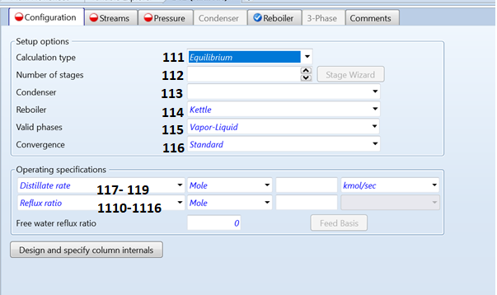

|  |  |  |  |  |
| --- | --- | --- | --- | --- |
| **Function description** | **Function name** | **Variable path** | **Function number** | **Extra Inputs** |
| Calculation Type | BLK_RADFRAC_Set  _CalculationType | Input.CALC_MODE  .Value | 111 | 1. RIG-RATE 2. EQUILIBRIUM |
| Number of Stages in Column | BLK_RADFRAC_Set_  NSTAGE | Input.NSTAGE.Value | 112 |  |
| Condenser type: | BLK_RADFRAC_Set  _CondenserType | Input.CONDENSER  .Value | 113 | 1. ”NONE” 2. ”TOTAL” 3. ”PARTIAL-V” 4. ”PARTIAL-V-L” |
| **DETERMINES THE CONDENSER INPUT VARIABELS NEEDED ON PAGE 4** | | | | |
| Reboiler type: | BLK_RADFRAC_Set  _CondenserType | Input.REBOILER.Value | 114 | 1. ”NONE” 2. ”KETTLE” 3. ”THERMOSYPHON” |
| **CHANGES THE CONDENSER INPUT VARIABELS NEEDED ON PAGE 5** | | | | |
| ValidPhase: | BLK_RADFRAC_Set_  Phases | Input.PHASE.Value  Input.NPHASE.Value | 115 | 1. “V” 2. “L” 3. “S”   And  1,2 or 3 |
| Convergence method | BLK_RADFRAC_Set_  ConvergenceMethod | Input.CONV_METH  .Value | 116 | 1. ”STANDARD” 2. ”PETROLEUM” 3. ”NONIDEAL” 4. ”AZEOTROPIC” 5. ”CRYOGENIC” 6. ”OTHERS” |
| Refluxratio | BLK_RADFRAC_Set_  Refluxratio | Input.BASIS_RR.Value | 117 |  |
| Refluxrate | BLK_RADFRAC_Set_  Refluxrate | Input.BASIS_L1.Value | 118 |  |
| Boilup flowrate | BLK_RADFRAC_Set_  BoilupRate | Input.BASIS_VN.Value | 119 |  |
| Boilup ratio (Boilup rate/Bottoms rate) | BLK_RADFRAC_Set_  BoilupRatio | Input.BASIS_BR.Value | 1110 |  |
| Condenser duty (negative means Q removal) | BLK_RADFRAC_Set_  CondenserDuty | Input.Q1.Value | 1111 |  |
| Reboiler duty | BLK_RADFRAC_Set_  ReboilerDuty | Input.QN.Value | 1112 |  |
| Total distillate flowrate | BLK_RADFRAC_Set_  TotalDestillateFlowrate | Input.BASIS_D.Value | 1113 |  |
| Liquid bottoms flow rate | BLK_RADFRAC_Set_  LiquidBottomRate | Input.BASIS.B.Value | 1114 |  |
| Destillate to Feed flow ratio | BLK_RADFRAC_Set_  DestillateToFeedRatio | Input.BASIS.D:F.Value | 1115 |  |
| Bottom to Feed flow ratio | BLK_RADFRAC_Set_  BottomToFeedRatio | Input.BASIS.B:F.Value | 1116 |  |

## Streams Page 2

|  |  |  |  |  |
| --- | --- | --- | --- | --- |
| **Function description** | **Function name** | **Variable path** | **Function number** | **Extra Inputs** |
| Feed stage for Feed | LK_RADFRAC_Set_  FeedStage | Input.FEED_STAGE  .Feedname.Value | 121 | Feedname |
| Feed stage Location | BLK_RADFRAC_Set  _FeedStageLocation | Input.FEED_CONVE2.  Feedname.Value | 122 | 1. ON-STAGE 2. ABOVE-STAGE 3. ON-STAGE-VAP 4. ON-STAGE-LIQ   Feedname |
| Product stage number | BLK_RADFRAC_Set  _ProductStreamStage | Input.PROD_STAGE.  Feedname.Value | 123 | Feedname |
| Product stream Phase: | BLK_RADFRAC_Set  _ProductPhase | Input.PROD_PHASE.  Feedname.Value | 124 | 1. L (Liquid) 2. L1 (1st liquid) 3. L2 (2nd liquid) 4. W (??) 5. V (Vapor) 6. TL (Total liquid) 7. TV (Total vapor)   Feedname |

## Pressures Page 3

|  |  |  |  |  |
| --- | --- | --- | --- | --- |
| **Function description** | **Function name** | **Variable path** | **Function number** | **Extra Inputs** |
| Pressure input perspective | BLK_RADFRAC_Set  _Pressure  PerspectiveOption | Input.VIEW_PRES  .Value | 131 | 1. TOP/BOTTOM 2. PROFILE 3. PDROP |
| **If you chose TOP/BOTTOM:** | | | | |
| Condenser pressure | BLK_RADFRAC_Set_  TOPBOTTOM_  CondenserPressure | Input.PRES1.Value | 132 |  |
| Condenser pressure drop | BLK_RADFRAC_Set_  TOPBOTTOM_  CondenserPressure  Drop | Input.PRES2.Value | 133 |  |
| Pressure drop per stage | BLK_RADFRAC_Set_  TOPBOTTOM  _StagePressureDrop | Input.DP_STAGE  .Value | 134 |  |
| **If you chose PROFILE** | | | | |
| Set pressure profile | BLK_RADFRAC_Set_  PROFILE_Pressure | Input.STAGE_PRES.**5**.Value = 0.1 | 135 | PressureList=[0.2,0.1] LocationList=[1,5] |
| **If you chose PDROP** | | | | |
| Top stage Pressure: | BLK_RADFRAC_Set_  PDROP_TopStage  Pressure | Input.PRES1.Value | 136 |  |
| Defining the PDrop profile | BLK_RADFRAC_Set_  PDROP_StagePDROP_Profile | Input.PRES_  STAGE1.**1**.Value = 2 | 137 | LocationList =[1,2]  StartingStageList=[2,7]  EndingStageList =[6,10]  PressureDropList=[0.1,0.2] |

IF TOP/BOTTOM is selected: only Condenser pressure is required for calculation

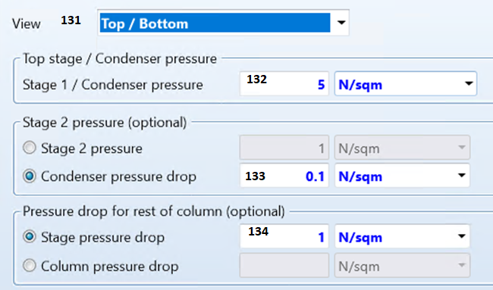

If Pressure PROFILE is selected:

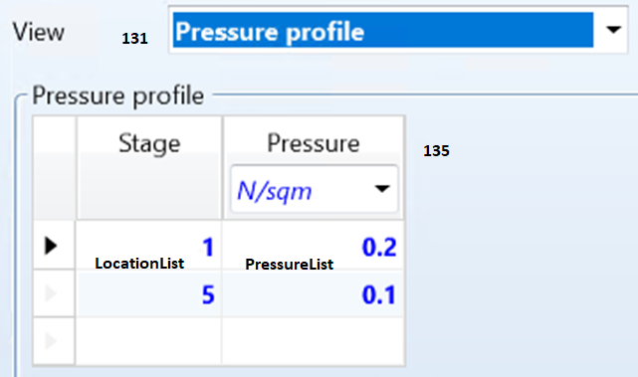

If PDROP is selected:

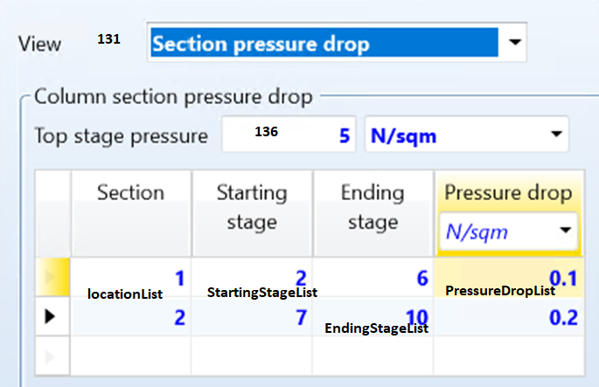

## Condenser Page 4

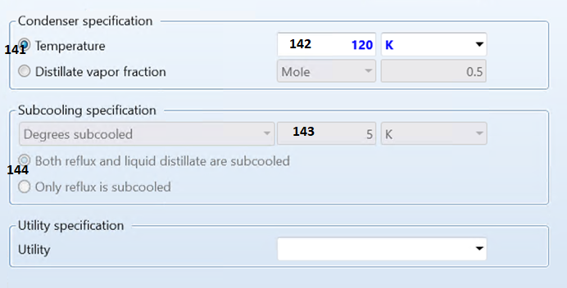

|  |  |  |  |  |
| --- | --- | --- | --- | --- |
| **Function description** | **Function name** | **Variable path** | **Function number** | **Extra Inputs** |
| **If NONE was chosen for Condenser Type: NO INPUTS NEEDED** | | | | |
| **If TOTAL or PARTIAL-V was chosen:** | | | | |
| Option for Subcooling specs is needed | BLK_RADFRAC_Set_  TOTALorPARTIALV_CondenserTempOption | Input.OPT_SUBCOOL  .Value | 141 | 1. TEMP 2. SUBCOOL |
|  | **If TEMP was chosen:** | | | |
| Temperature | BLK_RADFRAC_Set_  TOTALorPARTIALV_TEMP | Input.SC_TEMP.Value | 142 |  |
|  | **If SUBCOOL was chosen:** | | | |
| Degrees Subcooled | BLK_RADFRAC_Set_  TOTALorPARTIALV_SUBCOOL | Input.DEGSUB.Value | 143 |  |
| Destillate subcooling Option | BLK_RADFRAC_Set_  TOTALorPARTIALV_  CoolRefluxandDestillate | Input.SC_OPTION  .Value | 144 | 1. REFLUX-AND-DESTILLATE 2. REFLUX-ONLY |
| **if PARTIAL_V_L was chosen:** | | | | |
| Condenser Temperature Option | BLK_RADFRAC_Set_PARTIAL_V_L_CondenserTempOption | Input.OPT_SUBCOOL  .Value | 141 | 1. TEMP 2. SUBCOOL |
|  | **If TEMP was chosen for TempOption:** | | | |
| Temperature | BLK_RADFRAC_Set  _PARTIAL_V_L_TEMP | Input.SC_TEMP.Value | 142 |  |
|  | **If SUBCOOL was chosen for TempOption:** | | | |
| Degrees subcooled | BLK_RADFRAC_Set_PARTIAL_V_L_SUBCOOL | Input.DEGSUB.Value | 143 |  |
| Destillate subcooling Option | BLK_RADFRAC_Set_PARTIAL_V_L_CoolRefluxandDestillate | Input.SC_OPTION  .Value | 144 | 1. REFLUX-AND-DESTILLATE 2. REFLUX-ONLY |
| Condenser Option | BLK_RADFRAC_Set_PARTIAL_V_L_CondenserOption | Input.OPT_COND  .Value | 145 | 1. TEMP 2. VFRAC |
|  | **If you chose TEMP for Condenser Option:** | | | |
| Vapor Temp | BLK_RADFRAC_Set_PARTIAL_V_L_TEMP_VaporTemp | Input.T1.Value | 146 |  |
|  | **If you chose VFRAC for Condenser Option:** | | | |
| Vapor fraction | BLK_RADFRAC_Set_PARTIAL_V_L_TEMP_VaporFraction | Input. BASIS_RDV.Value | 147 |  |

## Reboiler Page 5

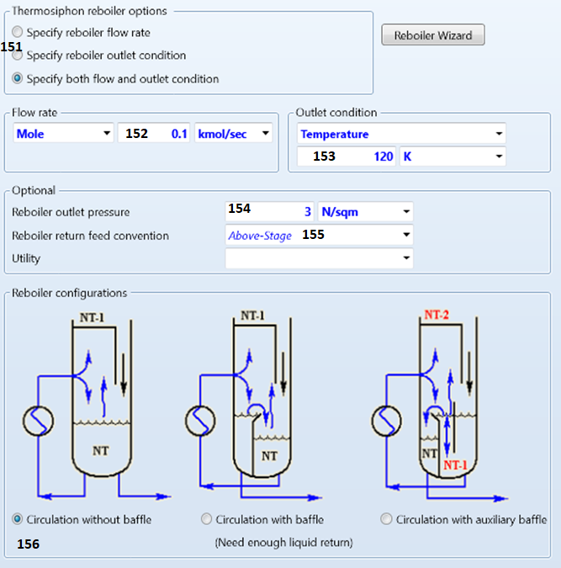

|  |  |  |  |  |  |
| --- | --- | --- | --- | --- | --- |
| **Function description** | **Function name** | **Variable path** | **Function number** | | **Extra Inputs** |
| **If you chose NONE or KETTLE on Page 1: no inputs needed** | | | | | |
| **If you chose THERMOSYPHON** | | | | | |
| Thermosyphon Options: | BLK_RADFRAC_Set_  THERMOSYPHON_OPTIONS | Input.OPT_TH_REB.Value | 151 | 1. FLOW 2. OUTLET 3. FLOW+OUTLET | |
|  | **If FLOW was selected:** | | | | |
| Set Flow | BLK_RADFRAC_Set_  THERMOSYPHON_FLOW | Input.TH_FLOW  .Value | 152 |  | |
|  | **If OUTLET was selected:** | | | | |
| Set Outlet temp | BLK_RADFRAC_Set_  THERMOSYPHON_OUTLET | Input.TH_TEMP  .Value | 153 |  | |
|  | **IF FLOW+OUTLET was selected:** | | | | |
| Set Flow | BLK_RADFRAC_Set_  THERMOSYPHON_FLOW | Input.TH_FLOW  .Value | 152 |  | |
| Set Outlet temp | BLK_RADFRAC_Set_  THERMOSYPHON_OUTLET | Input.TH_TEMP  .Value | 153 |  | |
| **Optional Parameters:** | | | | | |
| Outlet pressure | BLK_RADFRAC_Set_  ReboilerOutletPressure | Input.TH_PRES  .Value | 154 |  | |
| Reboiler return location | BLK_RADFRAC_Set_  ReboilerReturnLocation | Input.RETURN_  CONV.Value | 155 | 1. ABOVE-STAGE 2. ON-STAGE | |
| Reboiler configuration | BLK_RADFRAC_Set_  ReboilerConfiguration | Input.TSR  _CONFIG.Value | 156 | 1. 1 2. 2 3. 3 | |

# RADFRAC OUTPUTS

## Summary: Page 1 Output

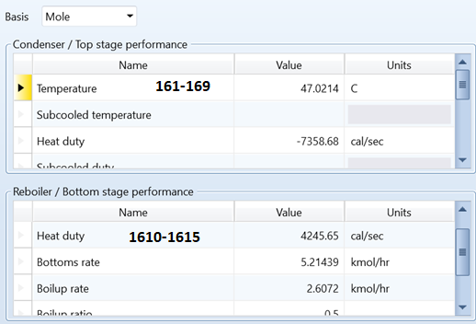

|  |  |  |  |
| --- | --- | --- | --- |
| **RADFRAC Outputs Page 1: Summary** | | | |
| **Function description** | **Function name** | **Path in Aspen** | **Function number** |
| **Condenser Data:** | | | |
| Condenser Temperature | BLK_RADFRAC_Get_Condenser_Temperature | Output. TOP_TEMP | 161 |
| Subcooled temperature | BLK_RADFRAC_Get_Condenser_SubcooledTemp | Output.SCTEMP | 162 |
| Heat duty: | BLK_RADFRAC_Get_Condenser_HeatingDuty | Output.COND_DUTY | 163 |
| Subcooled duty: | BLK_RADFRAC_Get_Condenser_SubcooledDuty | Output.SCDUTY | 164 |
| Distillate rate: | BLK_RADFRAC_Get_Condenser_DistillateRate | Output.MOLE_D | 165 |
| Reflux rate: | BLK_RADFRAC_Get_Condenser_RefluxRate | Output.MOLE_L1 | 166 |
| Free water distillate rate: | BLK_RADFRAC_Get_Condenser_  FreeWaterDistillateRate | Output.MOLE_DW | 167 |
| Free water reflux ratio: | BLK_RADFRAC_Get_Condenser_  FreeWaterRefluxRatio | Output.RW | 168 |
| Distillate to feed ratio: | BLK_RADFRAC_Get_Condenser  _DistillateToFeedRatio | Output.MOLE_DFR | 169 |
| **Reboiler Data:** | | | |
| Temperature: | BLK_RADFRAC_Get_Reboiler_Temperature | Output.BOTTOM_TEMP | 1610 |
| Heat duty: | BLK_RADFRAC_Get_Reboiler_HeatDuty | Output.REB_DUTY | 1611 |
| Bottoms rate: | BLK_RADFRAC_Get_Reboiler_BottomsRate | Output.MOLE_B | 1612 |
| Boilup rate: | BLK_RADFRAC_Get_Reboiler_BoilupRate | Output.MOLE_VN | 1613 |
| Boilup ratio: | BLK_RADFRAC_Get_Reboiler_BoilupRatio | Output.CMF_MAMX | 1614 |
| Bottoms to feed ratio: | LK_RADFRAC_Get_Reboiler  _BottomsToFeedRatio | Output.MOLE_BFR | 1615 |

## Balance: Page 2 Output

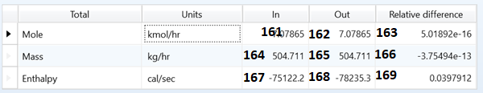

|  |  |  |  |
| --- | --- | --- | --- |
| **RADFRAC Outputs Page 2: Balance** | | | |
| **Function description** | **Function name** | **Path in Aspen** | **Function number** |
| Mole Balance: IN | BLK_RADFRAC_Get_MoleFlowBalanceIN() | Output.BAL_MOLI_TFL | 161 |
| Mole Balance: OUT | BLK_RADFRAC_Get_  MoleFlowBalanceOUT() | Output.BAL_MOLO_TFL | 162 |
| Mole Balance: Relative difference | BLK_ RADFRAC_Get_  MoleFlowBalanceRelDifference() | Output.BAL_MOLR_TFL | 163 |
| Mass Balance: IN | BLK_ RADFRAC_Get_  MassFlowBalanceIN() | Output.BAL_MASI_TFL. | 164 |
| Mass Balance: OUT | BLK_ RADFRAC_Get_  MassFlowBalanceOUT() | Output.BAL_MASO_TFL | 165 |
| Mass Balance: Relative difference | BLK_ RADFRAC_Get_  MassFlowBalanceRelDifference() | Output.BAL_MASR_TFL | 166 |
| Enthalpy: IN | BLK_ RADFRAC_Get_EnthalpyBalanceIN() | Output.TOT_ENTH_ABS | 167 |
| Enthalpy: OUT | BLK_RADFRAC_Get_EnthalpyBalanceOUT() | Output.BAL_ENTH_OUT | 168 |
| Enthalpy: Relative difference | BLK_ RADFRAC_Get_  EnthalpyBalanceRelDifference() | Output.TOT_ENTH_REL | 169 |

## Split fractions: Page 3 Output

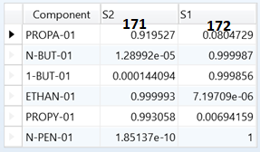

|  |  |  |  |  |
| --- | --- | --- | --- | --- |
| **RADFRAC Outputs Page 3: Split fractions** | | | | |
| **Function description** | **Function name** | **Path in Aspen** | **Function number** | **Inputs** |
| Splitfraction in Stream1 | BLK_RADFRAC_Get_SplitFractionInS1 | Output.MASS_CONC  .Compoundname.S1 | 171 | Compound name |
| Splitfraction in Stream2 | BLK_RADFRAC_Get_SplitFractionInS2 | Output.MASS_CONC  .Compoundname.S2 | 172 | Compound name |

## Reboiler: Page 4 Output

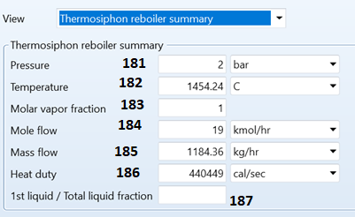

|  |  |  |  |
| --- | --- | --- | --- |
| **RADFRAC Outputs Page 4: Reboiler** | | | |
| **Function description** | **Function name** | **Path in Aspen** | **Function number** |
| Pressure: | BLK_RADFRAC_Get_  Thermosiphon_Pressure | Output.TH_PRES_OUT | 181 |
| Temperature: | BLK_RADFRAC_Get_  Thermosiphon_Temperature | Output.TH_TEMP_OUT | 182 |
| Molar vapor fraction: | BLK_RADFRAC_Get_  Thermosiphon_MolarVaporFraction | Output.TH_VFRAC_OUT | 183 |
| Molar flow: | BLK_RADFRAC_Get_  Thermosiphon_MolarFlow | Output.TH_MOLEFLOW | 184 |
| Mass flow: | BLK_RADFRAC_Get_  Thermosiphon_MassFlow | Output.TH_MASSFLOW | 185 |
| Heat duty: | BLK_RADFRAC_Get_  Thermosiphon_HeatDuty | Output.TH_DUTY | 186 |
| First liquid by Total liquid ratio: | BLK_RADFRAC_Get_  Thermosiphon_FirstliquidByTotalLiquidRatio | Output. LIQ_RATIO | 187 |

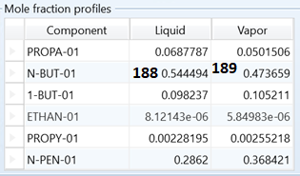

|  |  |  |  |  |
| --- | --- | --- | --- | --- |
| **RADFRAC Outputs Page 4: Mole fraction profiles** | | | | |
| **Function description** | **Function name** | **Path in Aspen** | **Function number** | **Input** |
| Liquid Reboiler fraction | BLK_RADFRAC_Get_  ReboilerMoleFractionInLiquid | Output.TH_X  .Compoundname.Value | 188 | Compound name |
| Vapor Reboiler fraction | BLK_RADFRAC_Get  _ReboilerMoleFractionInVapor | Output.TH_Y  .Compoundname.Value | 189 | Compound name |

## Utilities: Page 5 Output MISSING

MISSING

## Stage Utilities: Page 6 Output MISSING

## Status: Page 7 Output

|  |  |  |  |
| --- | --- | --- | --- |
| **RADFRAC Outputs Page 7: Status** | | | |
| **Function description** | **Function name** | **Path in Aspen** | **Function number** |
| Convergence status: | BLK_RADFRAC_Get_ConvergenceStatus | Output.BLKSTAT.Value = 0 | 191 |
| Convergence Message: | BLK_RADFRAC_Get_ConvergenceMessage | Output.BLKMSG.Value | 192 |
| Property status: | BLK_RADFRAC_Get_PropertyStatus | Output.PROPSTAT.Value=0 | 193 |

# Heater Input

## Specifications: Input Page 1

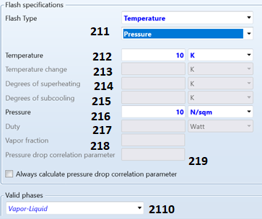

|  |  |  |  |  |
| --- | --- | --- | --- | --- |
| **Function description** | **Function name** | **Variable path** | **Function number** | **Extra Inputs** |
| Flash Type | BLK_HEATER_Set  _FlashTypeOption | Input.SPEC_OPT.Value | 211 | **See Below:** |
| Temperature | BLK_HEATER_Set  _Temperature | Input.TEMP.Value | 212 |  |
| Temp change | BLK_HEATER_Set  _TemperatureChange | Input.DELT.Value | 213 |  |
| Degree superheated | BLK_HEATER_Set  _DegreesSuperheating | Input.DEGSUP.Value | 214 |  |
| Degrees subcooled | BLK_HEATER_Set  _DegreesSubcooling | Input.DEGSUB.Value | 215 |  |
| Pressure | BLK_HEATER_Set  _Pressure | Input.PRES.Value | 216 |  |
| Duty | BLK_HEATER_Set  _Duty | Input.DUTY.Value | 217 |  |
| Vapor fraction | BLK_HEATER_Set  _Vaporfraction | Input.VFRAC.Value | 218 |  |
| Pressure drop correlation parameter | BLK_HEATER_Set  _PressureDropCorrelation | Input.DPPARM.Value | 219 |  |
| Valid Phases | BLK_HEATER_Set  _Phases | Input.PHASE.Value  Input.NPHASE.Value | 2110 | 1. “V” 2. “L” 3. “S”   And  1,2 or 3 |

## Flash Options Input Page 2:

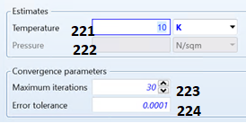

|  |  |  |  |  |
| --- | --- | --- | --- | --- |
| **Function description** | **Function name** | **Variable path** | **Function number** | **Extra Inputs** |
| Estimated Temperature | BLK_HEATER_Set_  TemperatureEstimation | Input.T_EST.Value | 221 |  |
| Estimated Pressure | BLK_HEATER_Set_  PressureEstimation | Input.P_EST.Value | 222 |  |
| Maximum iterations | BLK_HEATER_Set_  MaximumIteration | Input.MAXIT.Value | 223 |  |
| Error tolerance | BLK_HEATER_Set_  ErrorTolerance | Input.TOL.Value | 224 |  |

# Heater Output Missing

## Summary Page 1

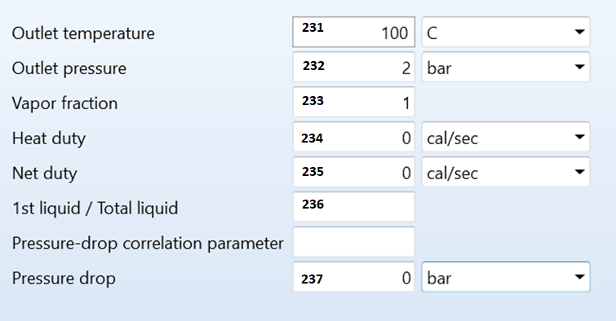

|  |  |  |  |
| --- | --- | --- | --- |
| **Mixer Outputs Page 1: Summary** | | | |
| **Function description** | **Function name** | **Path in Aspen** | **Function number** |
| Outlet temperature | BLK_HEATER_Get_OutletTemperature | Output.B_TEMP | 231 |
| Outlet pressure | BLK_HEATER_Get_OutletPressure | Outlet.B_PRES | 232 |
| Vapor fraction | BLK_HEATER_Get_VaporFraction | Outlet.B_VFRAC | 233 |
| First liquid by total liquid | BLK_HEATER_Get_FirstLiquidbyTotalLiquid | Outlet.LIQ_RATIO | 236 |
| Pressure drop | BLK_HEATER_Get_PressureDrop | Outlet.PDROP | 237 |

## Balance Page 2

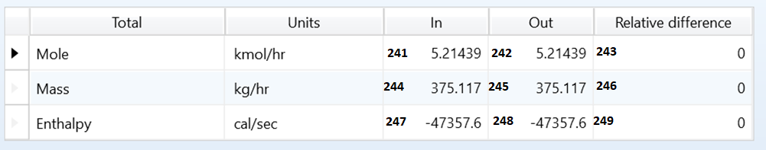

|  |  |  |  |
| --- | --- | --- | --- |
| **Function description** | **Function name** | **Path in Aspen** | **Function number** |
| Mole Balance: IN | BLK_ HEATER _Get  _MoleFlowBalanceIN() | Output.BAL_MOLI_TFL.Value | 241 |
| Mole Balance: OUT | BLK_ HEATER _Get  _MoleFlowBalanceOUT() | Output.BAL_MOLO_TFL.Value | 242 |
| Mole Balance: Relative difference | BLK_ HEATER _Get  _MoleFlowBalanceRelDifference() | Output.BAL_MOLR_TFL.Value | 243 |
| Mass Balance: IN | BLK_ HEATER _Get  _MassFlowBalanceIN | Output.BAL_MASI_TFL.Value | 244 |
| Mass Balance: OUT | BLK_ HEATER _Get  _MassFlowBalanceOUT | Output.BAL_MASO_TFL.Value | 245 |
| Mass Balance: Relative difference | BLK_ HEATER _Get  _MassFlowBalanceRelDifference | Output.BAL_MASR_TFL.Value | 246 |
| Enthalpy: IN | BLK_ HEATER _Get  _EnthalpyBalanceIN | Output.TOT_ENTH_ABS.Value | 247 |
| Enthalpy: OUT | BLK_ HEATER _Get  _EnthalpyBalanceOUT | Output.BAL_ENTH_OUT.Value | 248 |
| Enthalpy: Relative difference | BLK_ HEATER _Get  _EnthalpyBalanceRelDifference | Output.TOT_ENTH_REL.Value | 249 |

## Phase equilibrium Page 3

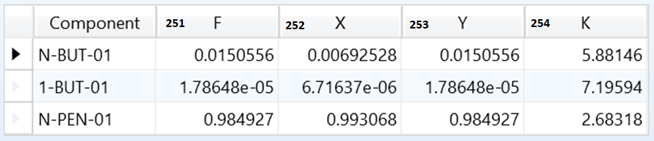

|  |  |  |  |  |
| --- | --- | --- | --- | --- |
| **Function description** | **Function name** | **Path in Aspen** | **Function number** | **Inputs** |
| Total Flow fraction | BLK_ HEATER_Get_  TotalFlowFraction() | Output.F.”Compoundname”.Value | 251 | Compound name |
| Liquid concentration: | BLK_ HEATER_Get_  Liquidconcentrations | Output.X.”Compoundname”.Value | 252 | Compound name |
| Vapor concentration: | BLK_ HEATER_Get_  Vaporconcentrations | Output.Y.”Compoundname”.Value | 253 | Compound name |
| Equilibrium constant: | BLK_HEATER_Get_  EquilibriumConstant | Output.B_K.”Compoundname”.Value | 254 | Compound name |

## Utilities Page 4

Not implemented yet

## Status Page 5

|  |  |  |  |
| --- | --- | --- | --- |
| **Function description** | **Function name** | **Path in Aspen** | **Function number** |
| Convergence status: | BLK_HEATER_Get_ConvergenceStatus | Output.BLKSTAT.Value = 0 | 261 |
| Convergence Message: | BLK_HEATER_Get_ConvergenceMessage | Output.BLKMSG.Value | 262 |
| Property status: | BLK_HEATER_Get_PropertyStatus | Output.PROPSTAT.Value = 0 | 263 |

# RPLUG Input

## Reactor type Input Page 1:

A) If T-SPEC is selected: Reactor maintains Temperature

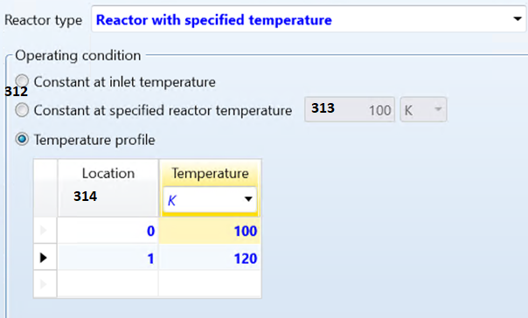

B) if ADIABATIC is selected: Reactor is thermally insulated

Nothing needs to be specified here.

C) if TCOOL-SPEC is selected: specified constant thermal fluid

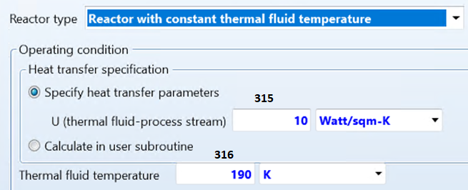

D) if CO-COOL is selected: Co current flow Process Stream

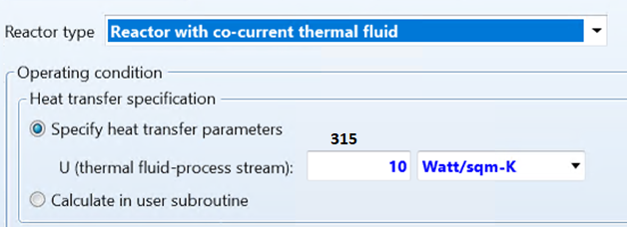

E) if COUNTER-COOL is selected: Counter current flow of thermal fluid

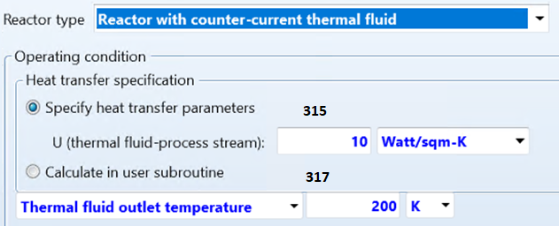

F) if TCOOL-PROF is selected: with defined Temperature Profile

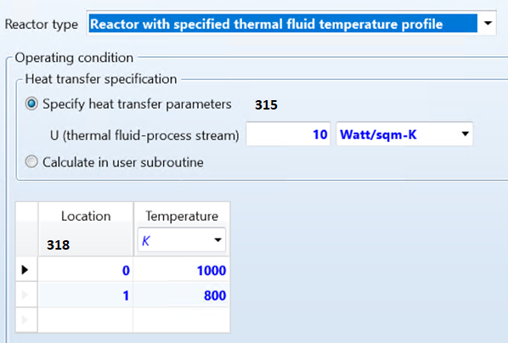

G) if QFLUX-PROF is selected: with defined heat flux profile

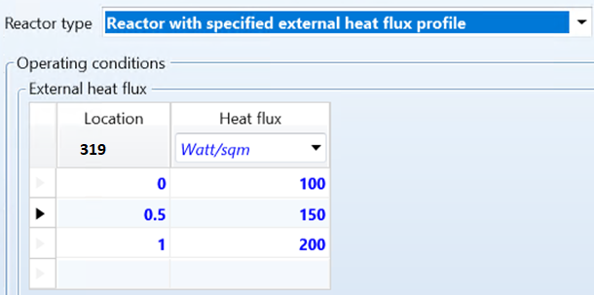

|  |  |  |  |  |
| --- | --- | --- | --- | --- |
| **Function description** | **Function name** | **Variable path** | **Function number** | **Extra Inputs** |
| Reactor type | BLK_RPLUG_Set_TYPE | Input.TYPE.Value | 311 | 1. “T-SPEC” 2. ”ADIABATIC” 3. ”TCOOL-SPEC” 4. “CO-COOL” 5. “TCOOL-PROF” 6. “QFLUX-PROF” |
| **If T-SPEC was chosen:** | | | | |
| Operating condition Option: | BLK_RPLUG_Set_T_SPEC  _Operating_condition | Input.OPT_TSPEC.Value | 312 | 1. INLET-TEMP 2. CONST-TEMP 3. TEMP-PROF |
|  | **If INLET-TEMP was chosen: no input needed** | | | |
|  | **If CONST-TEMP was chosen:** | | | |
| Constant Temperature | BLK_RPLUG_Set_T_SPEC  _Constant_Temp | Input.REAC_TEMP.Value | 313 |  |
|  | **If TEMP-PROF was chosen:** | | | |
| Setting Temperature Profile | BLK_RPLUG_Set_T_SPEC_  TemperatureProfil | Input.LOC.1.Value = 1 | 314 | TemperatureList  LocationList |
| **If ADIABATIC was chosen: no input needed** | | | | |
| **If TCOOL-SPEC was chosen:** | | | | |
| Heat transfer U | BLK_RPLUG_Set_TCOOL_SPEC_  HeattransferU | Input.U.Value | 315 |  |
| Constant Temperature | BLK_RPLUG_Set_TCOOL_  SPEC_ConstantTemp | Input.CTEMP.Value | 316 |  |
| **If CO-COOL was chosen:** | | | | |
| Heat transfer U | BLK_RPLUG_Set_CO_COOL_  HeattransferU | Input.U.Value | 315 |  |
| **If COUNTER-COOL was chosen:** | | | | |
| Heat transfer U | BLK_RPLUG_COUNTER_COOL  _HeattransferU | Input.U.Value | 315 |  |
| Outlet Temperature | BLK_RPLUG_Set_COUNTER  _COOL_OutletTemp | Input.TEMP | 317 |  |
| **If TCOOL-PROF was chosen:** | | | | |
| Heat transfer U | BLK_RPLUG_Set_TCOOL  _PROF_HeattransferU | Input.U.Value | 315 |  |
| Temperature Profile | BLK_RPLUG_Set_TCOOL_  PROF_TemperatureProfil | Input.TCOOL.#0.Value = 1000 | 318 | TemperatureList= [1000,800]  LocationList= [0,1] |
| **If QFLUX-PROF was chosen:** | | | | |
| Heat flux profile | BLK_RPLUG_Set_QFLUX_  PROF_HeatFluxProfil | Input.QFLUX.#0.Value = 100 | 319 | HeatFluxList=  [100, 150, 200]  LocationList = [0,0.5,1] |

## General Reactor Configurations Input Page 2:

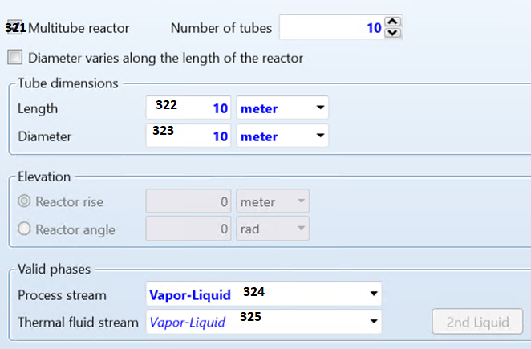

|  |  |  |  |  |
| --- | --- | --- | --- | --- |
| **Function description** | **Function name** | **Variable path** | **Function number** | **Extra Inputs** |
| Activate Multitubular design | BLK_RPLUG_Set_Activate_  Multitube_Reactor |  | 321 | Activate_YES_NO  Number_of_Tubes |
| Tube length | BLK_RPLUG_Set_TubeLength |  | 322 |  |
| Tube Diameter | BLK_RPLUG_Set_TubeDiameter |  | 323 |  |
| Stream Phase | BLK_RPLUG_Set_Phases |  | 324 | Phase number   1. 1 2. 2 3. 3   Phase   1. V 2. L |
| Phase of Thermal fluid | BLK_RPLUG_Set_  Thermalfluid_ValidPhases |  | 325 | Phase number   1. 1 2. 2 3. 3   Phase   1. V 2. L |

## Streams: Input Page 3:

|  |  |  |  |  |
| --- | --- | --- | --- | --- |
| **Function description** | **Function name** | **Variable path** | **Function number** | **Extra Inputs** |
| Productstream  phase | BLK_RPLUG_Set_  Productstream_phase | Input.PROD_PHASE.  ”STREAMNAME”.Value | 331 | Streamname  Possible Values:   1. V 2. L 3. L1 4. L2 5. W 6. VL 7. VL1 8. LW 9. L1L2 |

## Reactions: Input Page 4:

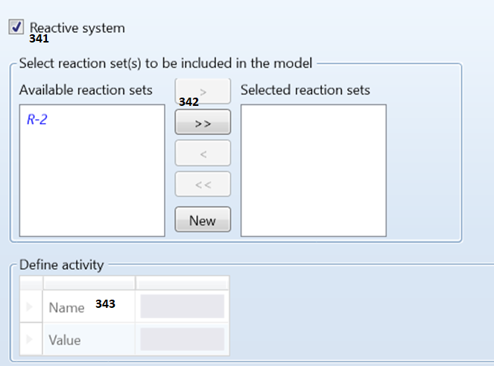

|  |  |  |  |  |
| --- | --- | --- | --- | --- |
| **Function description** | **Function name** | **Variable path** | **Function number** | **Extra Inputs/Options** |
| Activate Reactive System | BLK_RPLUG_Set_  ActivateReactions | Input.REACSYS.Value | 341 | 1. YES 2. NO |
| Add activities: | BLK_RPLUG_Set  _ReactionActivities | Input.ACT_VALUE.#0.Value | 343 | 1. ActivityList 2. ActivityNameList |

## Pressure specification Input Page 5:

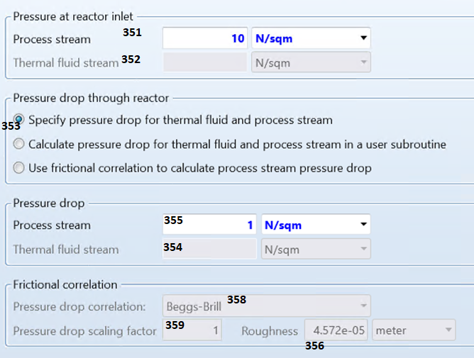

|  |  |  |  |  |
| --- | --- | --- | --- | --- |
| **Function description** | **Function name** | **Variable path** | **Function number** | **Extra Inputs/Options** |
| Reactor Inlet Processflow Pressure | BLK_RPLUG_Set_  InletProcessflow  Pressure | Input.PRES | 351 |  |
| Pressure at inlet for Thermal Fluid stream | BLK_RPLUG_Set  _InletThermalfluid  Pressure | Input.CPRES | 352 |  |
| Choose Pressure drop calculation Option | BLK_RPLUG_Set_  Pressuredrop  CalulationOption | Input.OPT_PDROP  .Value | 353 | 1. “SPECIFIED“ 2. “USER-SUBR“ 3. “CORRELATION“ |
| **If SPECIFIED is chosen:** | | | | |
| Thermal fluid pressure drop | BLK_RPLUG_Set_  SPECIFIED_Thermalfluid  PressureDrop | Input.CPDROP  .Value | 354 |  |
| Process flow pressure drop | BLK_RPLUG_Set_  SPECIGIED_Processflow  PressureDrop | Input.PDROP.Value | 355 |  |
| **If USER-SUBR is chosen:** | | | | |
| Roughness value for USERSUBR | BLK_RPLUG_Set_  USERSUBR_Roughnessvalue | Input.ROUGHNESS  .Value = 4.572E-05 | 356 |  |
| **If Correlation is chosen:** | | | | |
| Pressure drop of Thermalfluid | BLK_RPLUG_Set_  CORRELATION_  Thermalfluid  PressureDrop | Input.CPDROP | 357 |  |
| Pressure drop correlation | BLK_RPLUG_Set_  CORRELATION_  Pressuredrop  Correlation | Input.DP_FCOR  .Value | 358 | 1. BEGGS-BRILL 2. DUKLER 3. SLACK 4. ORKI 5. AWR 6. LOCK-MART 7. H-BROWN 8. DARCY 9. ERGUN 10. HTFS |
| Correction factor | BLK_RPLUG_Set_  CORRELATION  _CorrectionFactor | Input.DP_MULT  .Value = 1 | 359 |  |

## Reactor holdup Input Page 6:

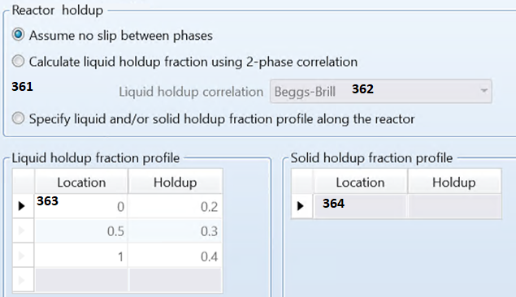

|  |  |  |  |  |
| --- | --- | --- | --- | --- |
| **Function description** | **Function name** | **Variable path** | **Function number** | **Extra Inputs/Options** |
| Option to choose the Hold up |  | Input.OPT_HOLDUP.Value | 361 | 1. NO-SLIP 2. CALCULATED 3. SPECIFIED: |
| **if you chose NO-SLIP: no imputs needed** | | | | |
| **if you chose CALCULATED:** | | | | |
| Liquid holdup correlation | BLK_RPLUG_Set_  CALCULATED  _HoldupCorrelation | Input.DP_HCOR.Value= | 362 | 1. BEGGS-BRILL 2. FLANIGAN 3. EATON 4. HOOG 5. HUGH 6. SLACK 7. ORKI 8. AWR 9. LOCK-MART 10. H-BROWN 11. USER-SUBR 12. HTFS |
| **if you chose SPECIFIED:** | | | | |
| Liquid Hold up profile | BLK_RPLUG_Set_  SPECIFIED  _HoldupProfilLIQUID | Input.HOLDUP.#0.Value =  Input.HLOCK.#1.Value = 1 | 363 | 1. HoldupList 2. LocationList |
| Solid Hold up Profile | BLK_RPLUG_Set_  SPECIFIED  _HoldupProfilSOLID | Input.SHLOC.#0.Value = 1  Input.SHOLDUP.#0.Value | 364 | 1. HoldupList 2. LocationList |

## Catalysts Input Page 7:

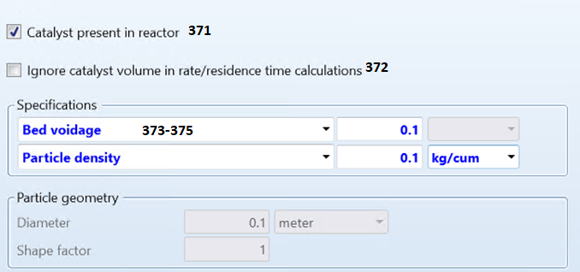

|  |  |  |  |  |
| --- | --- | --- | --- | --- |
| **Function description** | **Function name** | **Variable path** | **Function number** | **Extra Inputs/Options** |
| Activate Catalyst | BLK_RPLUG_Set  _CatalystPresent | Input.CAT_PRESENT.VALUE | 371 | 1. YES 2. NO |
| **If NO was chosen: no inputs are needed** | | | | |
| **If YES was chosen:** | | | | |
| Ignore Catalyst Volume? | BLK_RPLUG_Set_  IgnoreCatalystVolume | Input.IGN_CAT_VOL.Value | 372 | 1. YES 2. NO |
| Catalyst weight loaded | BLK_RPLUG_Set_  WeightOfCatalystLoaded | Input.CATWT.Value | 373 |  |
| Particle density | BLK_RPLUG_Set_  ParticleDensity | Input.CAT_RHO | 374 |  |
| Bed Void fraction | BLK_RPLUG_Set_  BedVoidage | Input.BED_VOIDAGE | 375 |  |

# RPLUG OUTPUT

## Summary: Page 1

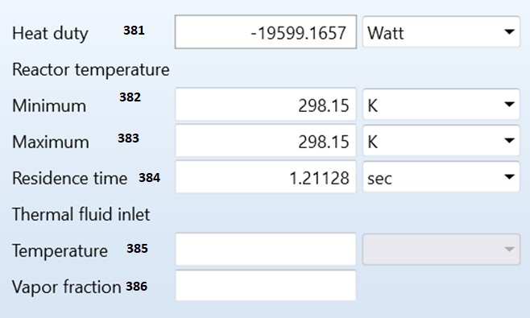

|  |  |  |  |
| --- | --- | --- | --- |
| **RPlug Outputs Page 1: Summary** | | | |
| **Function description** | **Function name** | **Path in Aspen** | **Function number** |
| Heat duty: | BLK_RPLUG_Get_Heatduty | Output.QCALC.Value | 381 |
| Minimum Reactor temperature: | BLK_RPLUG_Get_  MinimumReactorTemperature | Output.TMIN.Value | 382 |
| Maximum Reactor temperature: | BLK_RPLUG_Get_  MaximumReactorTemperature | Output.TMAX.Value | 383 |
| Residence time: | BLK_RPLUG_Get_ResidenceTime | Output.RES_TIME.Value | 384 |
| Thermal fluid Inlet temperature: | BLK_RPLUG_Get_  ThermalFluidInletTemperature | Output.COOLANT_TIN.Value | 385 |
| Thermal fluid Inlet Vapor fraction: | BLK_RPLUG_Get_  ThermalFluidInletVaporFraction | Output.COOLANT_VIN.Value | 386 |

## Balance: Page 2

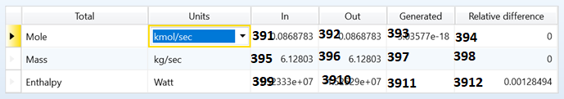

|  |  |  |  |
| --- | --- | --- | --- |
| **RPlug Outputs Page 2: Balance** | | | |
| **Function description** | **Function name** | **Path in Aspen** | **Function number** |
| Mole Balance: IN | BLK_RPLUG_Get  _MoleFlowBalanceIN() | Output.BAL_MOLI_TFL.Value | 391 |
| Mole Balance: OUT | BLK_ RPLUG_Get  _MoleFlowBalanceOUT() | Output.BAL_MOLO_TFL.Value | 392 |
| Mole Balance: Relative difference | BLK_ RPLUG_Get  _MoleFlowBalanceRelDifference() | Output.BAL_MOLR_TFL.Value | 393 |
| Mole Balance: Generated | BLK_ RPLUG_Get  _MoleFlowBalanceGenerated | Outpu. BAL_MOLG_TFL.Value | 394 |
| Mass Balance: IN | BLK_ RPLUG_Get  _MassFlowBalanceIN | Output.BAL_MASI_TFL.Value | 395 |
| Mass Balance: OUT | BLK_ RPLUG_Get  _MassFlowBalanceOUT | Output.BAL_MASO_TFL.Value | 396 |
| Mass Balance: Relative difference | BLK_ RPLUG_Get  _MassFlowBalanceRelDifference | Output.BAL_MASR_TFL.Value | 397 |
| Mass Balance: Generated | BLK_ RPLUG_Get  _MassFlowBalanceGenerated | Output. BAL_MASG_TFL.Value | 398 |
| Enthalpy: IN | BLK_ RPLUG_Get  _EnthalpyBalanceIN | Output.TOT_ENTH_ABS.Value | 399 |
| Enthalpy: OUT | BLK_ RPLUG_Get  _EnthalpyBalanceOUT | Output.BAL_ENTH_OUT.Value | 3910 |
| Enthalpy: Relative difference | BLK_ RPLUG_Get  _EnthalpyBalanceRelDifference | Output.TOT_ENTH_REL.Value | 3911 |
| Enthalpy: Generated | BLK_ RPLUG_Get  _EnthalpyBalanceGenerated | Output. BAL_ENTH_GEN.Value | 3912 |

## Distribution: Page 3 MISSING

## Polymer Attributes: Page 4 MISSING

## Status: Page 5

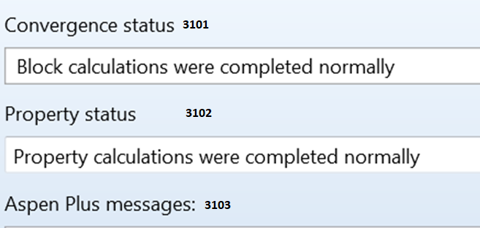

|  |  |  |  |
| --- | --- | --- | --- |
| **RPlug Outputs Page 5: Status** | | | |
| **Function description** | **Function name** | **Path in Aspen** | **Function number** |
| Convergence status: | BLK_RPLUG_Get_ConvergenceStatus() | Output.BLKSTAT.Value = 0 | 3101 |
| Convergence Message: | BLK_RPLUG_Get_ConvergenceMessage() | Output.BLKMSG.Value | 3102 |
| Property status: | BLK_RPLUG_Get_PropertyStatus() | Output.PROPSTAT.Value = 0 | 3103 |

# RCSTR Inputs

## Specifications Input Page 1:

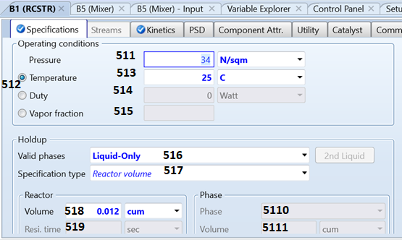

|  |  |  |  |  |
| --- | --- | --- | --- | --- |
| **Function description** | **Function name** | **Variable path** | **Function number** | **Extra Inputs/Options** |
| Pressure | BLK_CISTR_Set_Pressure | Input.PRES.Value | 511 |  |
| Input Option: |  | Input.SPEC_OPT | 512 | 1. TEMP 2. DUTY 3. VFRAC |
| **If TEMP was chosen:** | | | | |
|  | BLK_CISTR_Set_Temperature | Input.TEMP.Value | 513 |  |
| **If DUTY was chosen:** | | | | |
| Duty | BLK_CISTR_Set_Duty | Input.DUTY.Value | 514 |  |
| **If VFRAC was chosen:** | | | | |
| Vapor fraction | BLK_CISTR_Set_VaporFraction | Input.VFRAC.Value | 515 |  |
| Valid Phases: | BLK_CISTR_Set_Phases | Input.NPHASE.Value  Input.PHASE.Value | 516 | Phase number   1. 1 2. 2 3. 3   Phase   1. V 2. L |
| Specification type | BLK_CISTR_Set_Specification_type | Input.SPEC_TYPE  .Value | 517 | 1. TOT-VOL 2. RES-TIME 3. TOT-VOL-PH-VOL 4. TOT-VOL-PH-VOL-FRAC 5. TOT-VOL-PH-RES-TIME 6. RES-TIME-PH-VOL-FRAC 7. PH-RES-TIME-PH-VOL-FRAC |
| **If TOT-VOL chosen:** | | | | |
| Volume: | BLK_CISTR_Set_Volume | Input.VOL.Value | 518 |  |
| **If RES-TIME was chosen:** | | | | |
| Residence time: | BLK_CISTR_Set_  ResidenceTime | Input.RES_TIME  .Value | 519 |  |
| **If TOT-VOL-PH-VOL was chosen:** | | | | |
| Total volume | BLK_CISTR_Set_Volume | Input.VOL.Value | 518 |  |
| Phase that is held up | BLK_CISTR_Set_Specification_PhaseHoldup | Input.SPEC_PHASE | 5110 | 1. VAPOR 2. CONDENSED |
| Volume of the phase specified for Phase Holdup: | BLK_CISTR_Set_Volume_of_PhaseHoldup | Input.REACT_VOL | 5111 |  |
| **If TOT-VOL-PH-VOL-FRAC was chosen:** | | | | |
| Total volume | BLK_CISTR_Set_Volume | Input.VOL.Value | 518 |  |
| Phase that is held up | BLK_CISTR_Set_Specification_PhaseHoldup | Input.SPEC_PHASE | 5110 | 1. VAPOR 2. CONDENSED |
| Volume fraction of the phase specified for Phase Holdup | BLK_CISTR_Set_VolumeFrac_of_PhaseHoldup | Input.REACT_VOL_FR | 5112 |  |
| **If TOT-VOL-PH-RES-TIME was chosen:** | | | | |
| Total volume | BLK_CISTR_Set_Volume | Input.VOL.Value | 518 |  |
| Phase that is held up | BLK_CISTR_Set_Specification_PhaseHoldup | Input.SPEC_PHASE | 5110 | 1. VAPOR 2. CONDENSED |
| Residence time specified for Phase Holdup: | BLK_CISTR_Set_  Residencetime_of  _PhaseHoldup | Input.PH_RES_TIME | 5113 |  |
| **If RES-TIME-PH-VOL-FRAC was chosen:** | | | | |
| Residence time: |  | Input.RES_TIME | 519 |  |
| Phase that is held up | BLK_CISTR_Set_Specification_PhaseHoldup | Input.SPEC_PHASE | 5110 | 1. VAPOR 2. CONDENSED |
| Volume of the phase specified for Phase Holdup: | BLK_CISTR_Set_Volume_of_PhaseHoldup | Input.REACT_VOL | 5111 |  |
| **If PH-RES-TIME-PH-VOL-FRAC was chosen:** | | | | |
| Phase that is held up | BLK_CISTR_Set_Specification_PhaseHoldup | Input.SPEC_PHASE | 5110 | 1. VAPOR 2. CONDENSED |
| Volume fraction of the phase specified for Phase Holdup: | BLK_CISTR_Set_VolumeFrac_of_PhaseHoldup | Input.REACT_  VOL_FR | 5112 |  |
| Residence time specified for Phase Holdup: | BLK_CISTR_Set_Residencetime_of_PhaseHoldup | Input.PH_RES_TIME | 5113 |  |

## Streams Page 2:

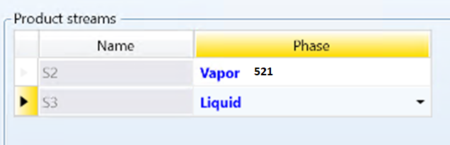

|  |  |  |  |  |
| --- | --- | --- | --- | --- |
| **Function description** | **Function name** | **Variable path** | **Function number** | **Extra Inputs** |
| Product stream  phase | BLK_CISTR_Set_  Productstream_phase | Input.PROD_PHASE.  ”STREAMNAME”.Value | 521 | Streamname  Possible Values:   1. V 2. L 3. L1 4. L2 5. W 6. VL 7. VL1 8. LW 9. L1L2 |

## Kinetics Page 3:

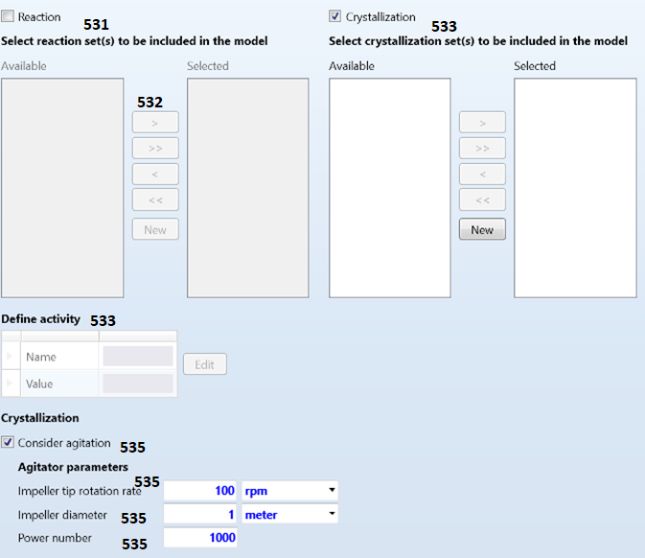

|  |  |  |  |  |
| --- | --- | --- | --- | --- |
| **Function description** | **Function name** | **Variable path** | **Function number** | **Extra Inputs/Options** |
| Activate Reactive System | BLK_CISTR_Set_  ActivateReactions | Input.REACSYS.Value | 531 | 1. YES 2. NO |
| Select Reaction Set: |  |  | 532 |  |
| Add activities: | BLK_CISTR_Set  _ReactionActivities | Input.ACT_VALUE.#0.Value | 533 | 1. ActivityList 2. ActivityNameList |
| Activate Crystallization System: | BLK_CISTR_Set_Activate_Crystalization | Input.CRYSTSYS.Value | 534 | 1. YES 2. NO |
| Include Agitation: | BLK_CISTR_Set_Activate_Agitation | Input.AGITATOR.Value  Input.AGITRATE.Value  Input.IMPELLR_DIAM.Value  Input.POWERNUMBER.Value | 535 | Rotationrate, ImpellerDiameter, Powernumber,  ActivateAgitation_or_not:   1. ”NO” 2. ”YES” |

## Particle Size Determination PSD Page 4:

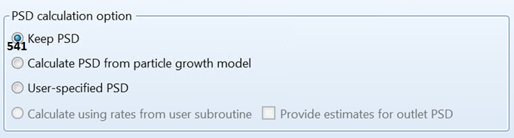

|  |  |  |  |  |  |  |  |
| --- | --- | --- | --- | --- | --- | --- | --- |
| **Function description** | **Function name** | | **Variable path** | | **Function number** | | **Extra Inputs/Options** |
| Calculation Options: | BLK_CISTR_Set_Calculation_Option | | Input.OPT_PSD | | 541 | | 1. COPY 2. CONSTANT 3. SPEC |
| **If you chose COPY: no input needed** | | | | | | | |
| **If you chose CONSTANT:** | | | | | | | |
| Growth model option | BLK_CISTR_Set_  ParticalGrowthModel | Input.  CONST_METHOD  .Value | | 542 | | A) “DELTAD-NUM“  Shift number distribution by same delta D  B) “DELTAD-MASS“  C) “DELTAV-NUM“  Shift number distribution by same delta V  D) “EQUI-MASS“  Mass distribution equivalent growth  E)“EQUI-SURFACE“  Surface distribution equivalent growth  F)“EQUI-NUMBER“  Number distribution equivalent growth | |
| **If SPEC was chosen: not implemented yet** | | | | | | | |

## Component Attributes Page 5 missing

Missing

## Utilities Page 6: missing

missing

## Catalyst Page 7:

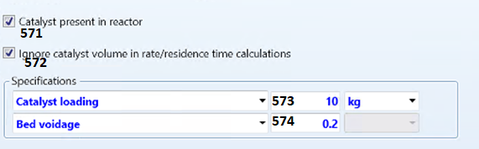

|  |  |  |  |  |
| --- | --- | --- | --- | --- |
| **Function description** | **Function name** | **Variable path** | **Function number** | **Extra Inputs/Options** |
| Activate Catalyst | BLK_CISTR_Set  _CatalystPresent | Input.CAT_PRESENT.VALUE | 571 | 1. YES 2. NO |
| **If NO was chosen: no inputs are needed** | | | | |
| **If YES was chosen:** | | | | |
| Ignore Catalyst Volume? | BLK_CISTR_Set_  IgnoreCatalystVolume | Input.IGN_CAT_VOL.Value | 572 | 1. YES 2. NO |
| Catalyst weight loaded | BLK_CISTR_Set_  WeightOfCatalystLoaded | Input.CATWT.Value | 573 |  |
| Particle density | BLK_CISTR_Set_  ParticleDensity | Input.CAT_RHO | 574 |  |

# RCSTR Output:

## Summary Page 1:

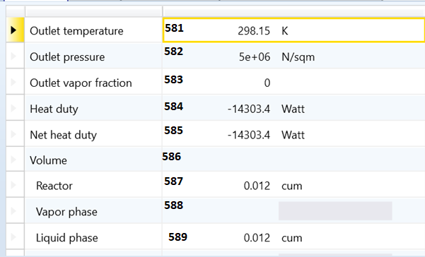

|  |  |  |  |
| --- | --- | --- | --- |
| **RCSTR Outputs Page 1: Summary** | | | |
| **Function description** | **Function name** | **Path in Aspen** | **Function number** |
| Outlet temperature: | LK_RCSTR_Get_OutletTemperature | Output.B_TEMP.Value | 581 |
| Outlet pressure: | BLK_RCSTR_Get_OutletPressure | Output.B_PRES.Value | 582 |
| Outlet vapor fraction: | BLK_RCSTR_Get_OutletVaporFraction | Output.B_VFRAC.Value | 583 |
| Heat duty: | BLK_RCSTR_Get_HeatDuty | Output.QCALC.Value | 584 |
| Net heat duty: | BLK_RCSTR_Get_NetHeatDuty | Output.QNET.Value | 585 |
| Reactor Volume: | BLK_RCSTR_Get_ReactorVolume | Output.TOT_VOL.Value | 586 |
| Vapor phase Volume: | BLK_RCSTR_Get_VaporPhaseVolume | Output.VAP_VOL.Value | 587 |
| Liquid phase Volume: | BLK_RCSTR_Get_LiquidPhaseVolume | Output.LIQ_VOL.Value | 588 |
| Liquid 1 phase volume: | BLK_RCSTR_Get_Liquid1PhaseVolume | Output.LIQ1_VOL | 589 |
| Salt phase volume: | BLK_RCSTR_Get_SaltPhaseVolume | Output.SALT_VOL | 5810 |
| Condensed phase volume: | BLK_RCSTR_Get  _CondensedPhaseVolume | Output.COND_VOL | 5811 |
| Reactor residence time: | BLK_RCSTR_Get  _ReactorResidenceTime | Output.TOT_RES_TIME | 5812 |
| Vapor phase residence time: | BLK_RCSTR_Get  _VaporPhaseResidenceTime | Output.VAP_RES_TIME | 5813 |
| Condensed phase residence time: | BLK_RCSTR_Get  _CondensedPhaseResidenceTime | Output.COND_RES_TIM | 5814 |

## Balance Page 2:

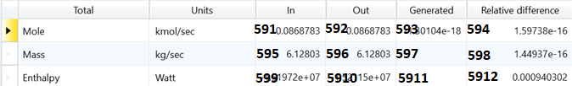

|  |  |  |  |
| --- | --- | --- | --- |
| **RCSTR Outputs Page 2: Balance** | | | |
| **Function description** | **Function name** | **Path in Aspen** | **Function number** |
| Mole Balance: IN | BLK_RCSTR_Get  _MoleFlowBalanceIN() | Output.BAL_MOLI_TFL.Value | 591 |
| Mole Balance: OUT | BLK_RCSTR _Get  _MoleFlowBalanceOUT() | Output.BAL_MOLO_TFL.Value | 592 |
| Mole Balance: Relative difference | BLK_ RCSTR _Get  _MoleFlowBalanceRelDifference() | Output.BAL_MOLR_TFL.Value | 593 |
| Mass Balance: IN | BLK_ RCSTR_Get  _MassFlowBalanceIN | Output.BAL_MASI_TFL.Value | 594 |
| Mass Balance: OUT | BLK_ RCSTR_Get  _MassFlowBalanceOUT | Output.BAL_MASO_TFL.Value | 595 |
| Mass Balance: Relative difference | BLK_ RCSTR_Get  _MassFlowBalanceRelDifference | Output.BAL_MASR_TFL.Value | 596 |
| Enthalpy: IN | BLK_ RCSTR_Get  _EnthalpyBalanceIN | Output.TOT_ENTH_ABS.Value | 597 |
| Enthalpy: OUT | BLK_ RCSTR_Get  _EnthalpyBalanceOUT | Output.BAL_ENTH_OUT.Value | 598 |
| Enthalpy: Relative difference | BLK_ RCSTR_Get  _EnthalpyBalanceRelDifference | Output.TOT_ENTH_REL.Value | 599 |

## Reaction Kinetics Page 3: missing

None of them can be extracted. It just gives an error “This function is not allowed for this variable.”

## Component Generation Rates Page 4: missing

Same error as Page 3

None of them can be extracted. It just gives an error “This function is not allowed for this variable.”

## Custom Reaction Variables Page 5: Missing

## Utility Usage Page 6: Missing

## Distributions Page 7: Missing

## Polymer Attributes Page 8: Missing

## Crystallization Page 9: Missing

## Status Page 10:

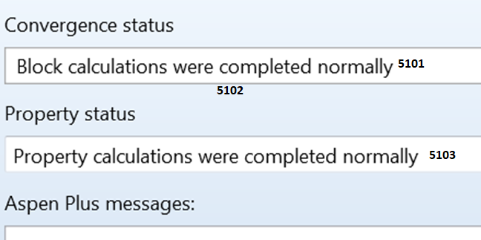

|  |  |  |  |
| --- | --- | --- | --- |
| **RCSTR Outputs Page 10: Status** | | | |
| **Function description** | **Function name** | **Path in Aspen** | **Function number** |
| Convergence status: | BLK_RCSTR_Get  _ConvergenceStatus | Output.BLKSTAT.Value = 0 | 5101 |
| Convergence Message: | BLK_RCSTR_Get  _ConvergenceMessage | Output.BLKMSG.Value | 5102 |
| Property status: | BLK_RCSTR_Get  _PropertyStatus | Output.PROPSTAT.Value = 0 | 5103 |

# Mixer Input

## Flash Option Page 1:

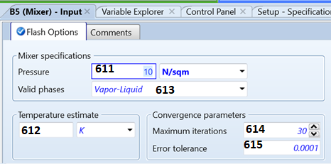

|  |  |  |  |  |
| --- | --- | --- | --- | --- |
| **Function description** | **Function name** | **Variable path** | **Function number** | **Extra Inputs/ Options** |
| Pressure: | BLK_MIXER_Set_Pressure | Input.PRES.Value | 611 |  |
| Temperature Estimate | BLK_MIXER_Set_  TemperatureEstimate | Input.T_EST.Value | 612 |  |
| Number of Phases and Phase: | BLK_MIXER_Set_Phases | Input.NPhase.Value  Input.Phase.Value | 613 |  |
| Maximum iterations: | BLK_MIXER_Set_  MaximumIteration | Input.MAXIT.Value | 614 |  |
| Error tolerance: | BLK_MIXER_Set_  ErrorTolerance | Input.TOL.Value | 615 |  |

# MIXER Output

## Summary Page 1:

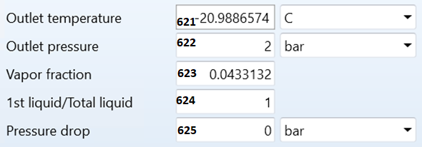

|  |  |  |  |
| --- | --- | --- | --- |
| **Mixer Outputs Page 1: Summary** | | | |
| **Function description** | **Function name** | **Path in Aspen** | **Function number** |
| Outlet temperature | BLK_MIXER_Get_OutletTemperature | Output.B_TEMP | 621 |
| Outlet pressure | BLK_MIXER_Get_OutletPressure | Outlet.B_PRES | 622 |
| Vapor fraction | BLK_MIXER_Get_VaporFraction | Outlet.B_VFRAC | 623 |
| First liquid by total liquid | BLK_MIXER_Get_FirstLiquidbyTotalLiquid | Outlet.LIQ_RATIO | 624 |
| Pressure drop | BLK_MIXER_Get_PressureDrop | Outlet.PDROP | 625 |

## Balance Page 2:

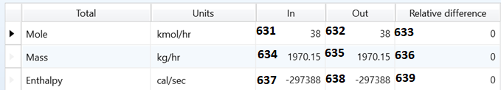

|  |  |  |  |
| --- | --- | --- | --- |
| **Mixer Outputs Page 2: Balance** | | | |
| **Function description** | **Function name** | **Path in Aspen** | **Function number** |
| Mole Balance: IN | BLK_MIXER_Get_MoleFlowBalanceIN | Output.BAL_MOLI_TFL | 631 |
| Mole Balance: OUT | BLK_MIXER_Get_  MoleFlowBalanceOUT | Output.BAL_MOLO_TFL | 632 |
| Mole Balance: Relative difference | BLK_MIXER_Get_  MoleFlowBalanceRelDifference | Output.BAL_MOLR_TFL | 633 |
| Mass Balance: IN | BLK_MIXER_Get_  MassFlowBalanceIN | Output.BAL_MASI_TFL | 634 |
| Mass Balance: OUT | BLK_MIXER_Get_  MassFlowBalanceOUT | Output.BAL_MASO_TFL | 635 |
| Mass Balance: Relative difference | BLK_MIXER_Get_  MassFlowBalanceRelDifference | Output.BAL_MASR_TFL | 636 |
| Enthalpy: IN | BLK_MIXER_Get_EnthalpyBalanceIN | Output.TOT_ENTH_ABS | 637 |
| Enthalpy: OUT | BLK_MIXER_Get_EnthalpyBalanceOUT | Output.BAL_ENTH_OUT | 638 |
| Enthalpy: Relative difference | BLK_MIXER_Get_  EnthalpyBalanceRelDifference | Output.TOT_ENTH_REL | 639 |

## Status Page 3:

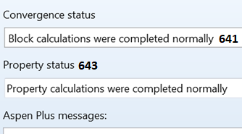

|  |  |  |  |
| --- | --- | --- | --- |
| **Mixer Outputs Page 7: Status** | | | |
| **Function description** | **Function name** | **Path in Aspen** | **Function number** |
| Convergence status: | BLK_MIXER_Get_ConvergenceStatus() | Output.BLKSTAT.Value = 0 | 641 |
| Convergence Message: | BLK_MIXER_Get_ConvergenceMessage() | Output.BLKMSG.Value | 642 |
| Property status: | BLK_MIXER_Get_PropertyStatus() | Output.PROPSTAT.Value = 0 | 643 |

# RYIELD Input

## Specifications Page 1

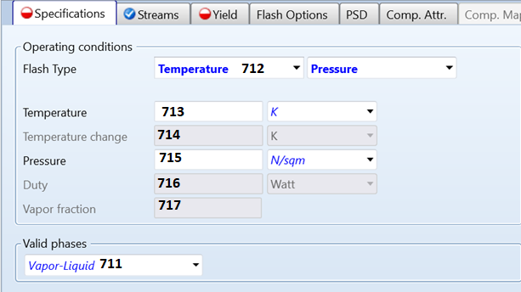

|  |  |  |  |  |
| --- | --- | --- | --- | --- |
| **Function description** | **Function name** | **Variable path** | **Function number** | **Extra Inputs/Options** |
| Valid phase | BLK_RYIELD_Set_Phases | Input.PHASE.Value  Input.NPHASE.Value | 711 |  |
| Flash Type Option | BLK_RYIELD_Set_  FlashTypeOption | Input.SPEC_OPT | 712 | 1. TP 2. TV 3. PV 4. TD 5. PD 6. PQ ? 7. TQ ? 8. DTP 9. DTV 10. DTD 11. DTQ ? |
| **For the given Input choice, the following inputs can be set:** | | | | |
| Temperature  T | BLK_RYIELD_Set_Temperature | Input.TEMP.Value | 713 |  |
| Pressure  P | BLK_RYIELD_Set_Pressure | Input.PRES.Value | 714 |  |
| Temperature change  DT | BLK_RYIELD_Set_  TemperatureChange | Input.DELT.Value | 715 |  |
| Duty  D | BLK_RYIELD_Set_Duty | Input.DUTY.Value | 716 |  |
| Vapor fraction  V | BLK_RYIELD_Set_  Vaporfraction | Input.VFRAC.Value | 717 |  |

## Streams Page 2:

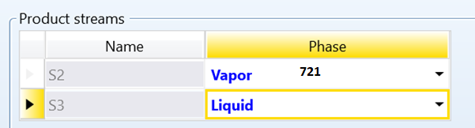

This is only necessary if you have two Output streams:

|  |  |  |  |  |
| --- | --- | --- | --- | --- |
| **Function description** | **Function name** | **Variable path** | **Function number** | **Extra Inputs** |
| Product stream  phase | BLK_RYIELD_Set_  PhaseOfProductStream | Input.PROD_PHASE.  ”STREAMNAME”.Value | 721 | Streamname  Possible Values:   1. V 2. L 3. L1 4. L2 5. W 6. VL 7. VL1 8. LW 9. L1L2 |

## Yield Page 3:

A) If Component yields were selected:

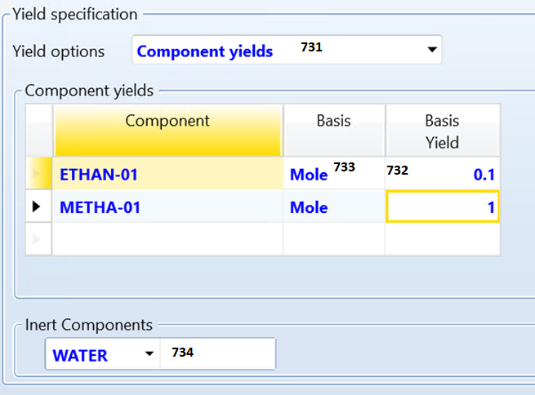

|  |  |  |  |  |
| --- | --- | --- | --- | --- |
| **Function description** | **Function name** | **Variable path** | **Function number** | **Extra Inputs** |
| Yield options: | BLK_RYIELD_Set_  YieldCalcOption | Input.USER_YIELD.Value | 731 | 1. Component yields “NO“ 2. User Subroutine “YES“ 3. Component mapping “NO2“ 4. Petro characterization “NO3“ |
| **If Component yield was chosen:** | | | | |
| Setting the Yield per Basis flow: | BLK_RYIELD_Set_  ComponentYield_  YieldPerFlow | Input.MOLE_YIELD.”ETHAN-01 MIXED”.Value | 732 |  |
| Changing the Basis: | BLK_RYIELD_Set  _ComponentYield_  ChangeBasis | Input.BASIS.”METHA-01 MIXED”.Value | 733 | 1. “MASS” 2. “MOLE” |
| Setting Inert Components: | BLK_RYIELD_Set_  ComponentYield_  InertComponent | Input.COMP_LIST.#0.Value = WATER | 734 |  |
| **If User Subroutine was selected: not implemented yet** | | | | |
| **If Component mapping was selected: not implemented yet** | | | | |
| **If Petro characterization was selected: not implemented yet** | | | | |

## Flash Options Page 4:

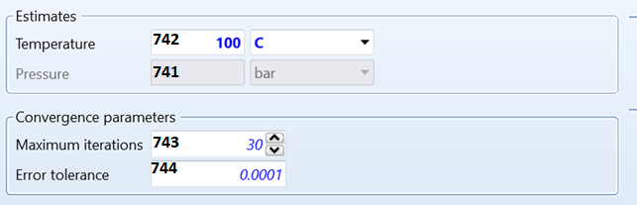

|  |  |  |  |  |
| --- | --- | --- | --- | --- |
| **Function description** | **Function name** | **Variable path** | **Function number** | **Extra Inputs/Options** |
| Estimation of the Pressure: | BLK_RYIELD_Set_Temperature  Estimation | Input.PRES.Value | 741 |  |
| Temperature Estimate | BLK_RYIELD_Set_Pressure  Estimation | Input.T_EST.Value | 742 |  |
| Maximum iterations: | BLK_RYIELD_Set_  MaximumIteration | Input.MAXIT.Value | 743 |  |
| Error tolerance: | BLK_RYIELD_Set_  ErrorTolerance | Input.TOL.Value | 744 |  |

## Particle Size Determination PSD Page 5:

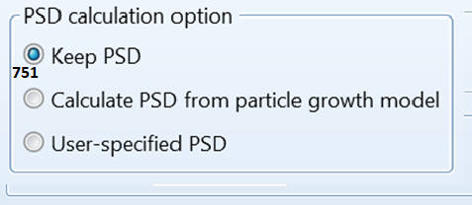

|  |  |  |  |  |
| --- | --- | --- | --- | --- |
| **Function description** | **Function name** | **Variable path** | **Function number** | **Extra Inputs/Options** |
| Calculation Options: | BLK_RYIELD_Set_  Calculation_Option | Input.OPT_PSD | 751 | 1. COPY 2. CONSTANT 3. SPEC |
| **If you chose COPY: no input needed** | | | | |
| **If you chose CONSTANT:** | | | | |
| Growth model option | BLK_RYIELD_Set_  ParticalGrowthModel | Input.CONST_METHOD  .Value | 752 | A) “DELTAD-NUM“  Shift number distribution by same delta D  B) “DELTAD-MASS“  C) “DELTAV-NUM“  Shift number distribution by same delta V  D) “EQUI-MASS“  Mass distribution equivalent growth  E)“EQUI-SURFACE“  Surface distribution equivalent growth  F)“EQUI-NUMBER“  Number distribution equivalent growth |
| **If SPEC was chosen: not clear** | | | | |

## Component Attribute Page 6

missing

## Component mapping Page 7

missing

# RYIELD Output:

## Summary Page 1:

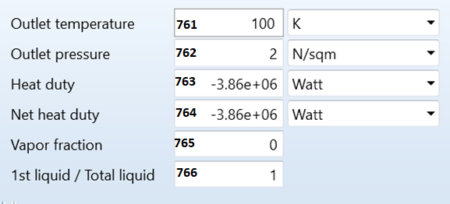

|  |  |  |  |
| --- | --- | --- | --- |
| **RYield Outputs Page 1: Summary** | | | |
| **Function description** | **Function name** | **Path in Aspen** | **Function number** |
| Outlet temperature: | BLK_RYIELD_Get_OutletTemperature | Output.B_TEMP | 761 |
| Outlet pressure: | BLK_RYIELD_Get_OutletPressure | Output.B_PRES | 762 |
| Heat duty: | BLK_RYIELD_Get_HeatDuty | Output.QCALC | 763 |
| Net heat duty: | BLK_RYIELD_Get_NetHeatDuty | Output.QNET | 764 |
| Vapor fraction: | BLK_RYIELD_Get_VaporFraction | Output.B_VFRAC | 765 |
| 1st liquid to total liquid fraction: | BLK_RYIELD_Get_  FirstLiquidbyTotalLiquidFraction | Output.LIQ_RATIO | 766 |

## Balance Page 2:

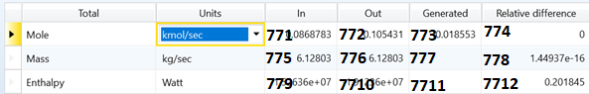

|  |  |  |  |
| --- | --- | --- | --- |
| **RYield Outputs Page 2: Balance** | | | |
| **Function description** | **Function name** | **Path in Aspen** | **Function number** |
| Mole Balance: IN | BLK_RYIELD_Get  _MoleFlowBalanceIN() | Output.BAL_MOLI_TFL.Value | 771 |
| Mole Balance: OUT | BLK_RYIELD_Get  _MoleFlowBalanceOUT() | Output.BAL_MOLO_TFL.Value | 772 |
| Mole Balance: Relative difference | BLK_RYIELD_Get  _MoleFlowBalanceRelDifference() | Output.BAL_MOLR_TFL.Value | 773 |
| Mole Balance: Generated | BLK_RYIELD_Get  _MoleFlowBalanceGenerated | Outpu. BAL_MOLG_TFL.Value | 774 |
| Mass Balance: IN | BLK_RYIELD_Get  _MassFlowBalanceIN | Output.BAL_MASI_TFL.Value | 775 |
| Mass Balance: OUT | BLK_RYIELD_Get  _MassFlowBalanceOUT | Output.BAL_MASO_TFL.Value | 776 |
| Mass Balance: Relative difference | BLK_RYIELD_Get  _MassFlowBalanceRelDifference | Output.BAL_MASR_TFL.Value | 777 |
| Mass Balance: Generated | BLK_RYIELD_Get  _MassFlowBalanceGenerated | Output. BAL_MASG_TFL.Value | 778 |
| Enthalpy: IN | BLK_RYIELD_Get  _EnthalpyBalanceIN | Output.TOT_ENTH_ABS.Value | 779 |
| Enthalpy: OUT | BLK_RYIELD_Get  _EnthalpyBalanceOUT | Output.BAL_ENTH_OUT.Value | 7710 |
| Enthalpy: Relative difference | BLK_RYIELD_Get  _EnthalpyBalanceRelDifference | Output.TOT_ENTH_REL.Value | 7711 |
| Enthalpy: Generated | BLK_RYIELD_Get  _EnthalpyBalanceGenerated | Output. BAL_ENTH_GEN.Value | 7712 |

## Phase Equilibrium Page 3:

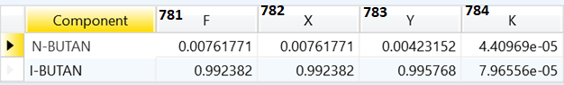

|  |  |  |  |  |
| --- | --- | --- | --- | --- |
| **RYield Outputs Page 3: Phase Equilibrium** | | | | |
| **Function description** | **Function name** | **Path in Aspen** | **Function number** | **Inputs** |
| Total Flow fraction | BLK_RYIELD_Get_  TotalFlowFraction() | Output.F.”Compoundname”  .Value | 781 | Compound name |
| Liquid concentration: | BLK_RYIELD_Get_  Liquidconcentrations() | Output.X.”Compoundname”  .Value | 782 | Compound name |
| Vapor concentration: | BLK_RYIELD_Get_  Vaporconcentrations() | Output.Y.”Compoundname”  .Value | 783 | Compound name |
| Equilibrium constant: | BLK_RYIELD_Get_  EquilibriumConstant() | Output.B_K.”Compoundname”  .Value | 784 | Compound name |

## Weight distribution Page 4: missing

## Pseudocomp Breakdown Page 5: missing

## Utility usage Page 6: missing

## Status Page 7:

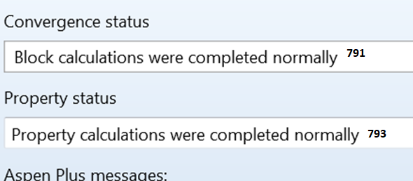

|  |  |  |  |
| --- | --- | --- | --- |
| **RYield Outputs Page 5: Status** | | | |
| **Function description** | **Function name** | **Path in Aspen** | **Function number** |
| Convergence status: | BLK_RYIELD_Get_ConvergenceStatus() | Output.BLKSTAT.Value = 0 | 791 |
| Convergence Message: | BLK_RYIELD_Get_ConvergenceMessage() | Output.BLKMSG.Value | 792 |
| Property status: | BLK_RYIELD_Get_PropertyStatus() | Output.PROPSTAT.Value = 0 | 793 |

# FLASH2 Input

## Specifications Page 1:

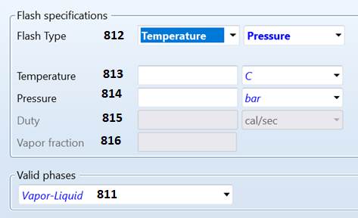

|  |  |  |  |  |  |
| --- | --- | --- | --- | --- | --- |
| **Function description** | **Function name** | **Variable path** | | **Function number** | **Extra Inputs/Options** |
| Valid phase | BLK_FLASH2_Set_Phases | Input.PHASE.Value  Input.NPHASE.Value | | 811 |  |
| Flash Type Option | BLK_FLASH2_Set_  FlashTypeOption | Input.SPEC_OPT | | 812 | 1. TP 2. TV 3. PV 4. TD 5. PD 6. PQ ? 7. TQ ? |
| **For the given Input choice the following inputs can be set:** | | | | | |
| Temperature  T | BLK_FLASH2_Set_Temperature | | Input.TEMP.Value | 813 |  |
| Pressure  P | BLK_FLASH2_Set_Pressure | | Input.PRES.Value | 814 |  |
| Duty  D | BLK_FLASH2_Set_Duty | | Input.DUTY.Value | 815 |  |
| Vapor fraction  V | BLK_FLASH2_Set_Vapor_fraction | | Input.VFRAC.Value | 816 |  |

## Flash Option Page 2:

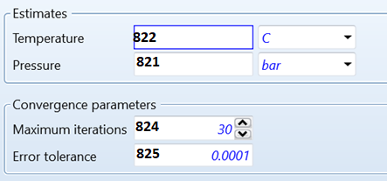

|  |  |  |  |  |
| --- | --- | --- | --- | --- |
| **Function description** | **Function name** | **Variable path** | **Function number** | **Extra Inputs/Options** |
| Pressure: | BLK_FLASH2_Set_  PressureEstimation | Input.PRES.Value | 821 |  |
| Temperature Estimate | BLK_FLASH2_Set_  TemperatureEstimation | Input.T_EST.Value | 822 |  |
| Maximum iterations: | BLK_FLASH2_Set_  MaximumIteration | Input.MAXIT.Value | 824 |  |
| Error tolerance: | BLK_FLASH2_Set_  ErrorTolerance | Input.TOL.Value | 825 |  |

## Entrainment Page 3:

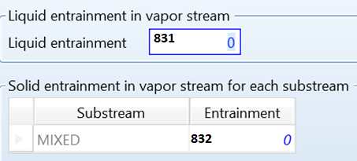

|  |  |  |  |  |
| --- | --- | --- | --- | --- |
| **Function description** | **Function name** | **Variable path** | **Function number** | **Extra Inputs/Options** |
| Liquid Entrainment | BLK_FLASH2_Set_  PressureEstimation | Input.ENTRN.Value | 831 |  |
| Solid Entrainment | BLK_FLASH2_Set_  TemperatureEstimation | Input.VAPOR.MIXED.Value | 832 |  |

## Particle Size Determination (PSD) Page 4:

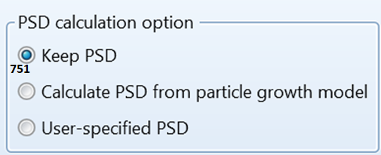

|  |  |  |  |  |
| --- | --- | --- | --- | --- |
| **Function description** | **Function name** | **Variable path** | **Function number** | **Extra Inputs/Options** |
| Calculation Options: | BLK_FLASH2_Set_  Calculation_Option | Input.OPT_PSD | 841 | 1. COPY 2. CONSTANT 3. SPEC |
| **If you chose COPY: no input needed** | | | | |
| **If you chose CONSTANT:** | | | | |
| Growth model option | BLK_FLASH2_Set_  ParticalGrowthModel | Input.CONST_METHOD  .Value | 842 | A) “DELTAD-NUM“  Shift number distribution by same delta D  B) “DELTAD-MASS“  C) “DELTAV-NUM“  Shift number distribution by same delta V  D) “EQUI-MASS“  Mass distribution equivalent growth  E)“EQUI-SURFACE“  Surface distribution equivalent growth  F)“EQUI-NUMBER“  Number distribution equivalent growth |
| **If SPEC was chosen: not clear** | | | | |

## Utilities Page 5:

# FLASH2 Output:

## Summary PAGE 1

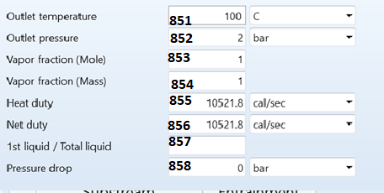

|  |  |  |  |
| --- | --- | --- | --- |
| **Flash2 Outputs Page 1: Summary** | | | |
| **Function description** | **Function name** | **Path in Aspen** | **Function number** |
| Outlet temperature: | BLK_FLASH2_Get_OutletTemperature | Output.B_TEMP | 851 |
| Outlet pressure: | BLK_FLASH2_Get_OutletPressure | Output.B_PRES | 852 |
| Vapor fraction (mole): | BLK_FLASH2_Get_VaporFractionMole | Output.B_VFRAC | 853 |
| Vapor fraction (mass): | BLK_FLASH2_Get_VaporFractionMass | Output.MVFRAC | 854 |
| Heating duty: | BLK_FLASH2_Get_HeatingDuty | Output.QCALC | 855 |
| Net duty: | BLK_FLASH2_Get_NetDuty | Output.QNET | 856 |
| 1st liquid/Total liquid: | LK_FLASH2_Get_  FirstLiquidtoTotalLiquidRatio | Output.LIQ_RATIO | 857 |
| Pressure drop: | BLK_FLASH2_Get_PressureDrop | Output.PDROP | 858 |

## Balance PAGE 2:

Same as the other Balances

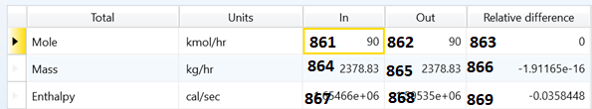

|  |  |  |  |
| --- | --- | --- | --- |
| **Flash2 Outputs Page 2: Balance** | | | |
| **Function description** | **Function name** | **Path in Aspen** | **Function number** |
| Mole Balance: IN | BLK_FLASH2_Get_MoleFlowBalanceIN() | Output.BAL_MOLI_TFL.Value | 861 |
| Mole Balance: OUT | BLK_FLASH2_Get_  MoleFlowBalanceOUT() | Output.BAL_MOLO_TFL.Value | 862 |
| Mole Balance: Relative difference | BLK_FLASH2_Get_  MoleFlowBalanceRelDifference() | Output.BAL_MOLR_TFL.Value | 863 |
| Mass Balance: IN | BLK_FLASH2_Get_  MassFlowBalanceIN() | Output.BAL_MASI_TFL.Value | 864 |
| Mass Balance: OUT | BLK_FLASH2_Get_  MassFlowBalanceOUT() | Output.BAL_MASO_TFL.Value | 865 |
| Mass Balance: Relative difference | BLK_FLASH2_Get_  MassFlowBalanceRelDifference() | Output.BAL_MASR_TFL.Value | 866 |
| Enthalpy: IN | BLK_FLASH2_Get_EnthalpyBalanceIN() | Output.TOT_ENTH_ABS.Value | 867 |
| Enthalpy: OUT | BLK_FLASH2_Get_  EnthalpyBalanceOUT() | Output.BAL_ENTH_OUT.Value | 868 |
| Enthalpy: Relative difference | BLK_FLASH2_Get_  EnthalpyBalanceRelDifference() | Output.TOT_ENTH_REL.Value | 869 |

## Phase Equilibrium PAGE 3:

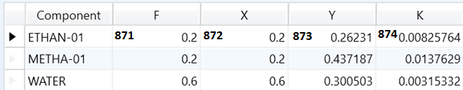

|  |  |  |  |  |
| --- | --- | --- | --- | --- |
| **Flash2 Outputs Page 3: Phase Equilibrium** | | | | |
| **Function description** | **Function name** | **Path in Aspen** | **Function number** | **Inputs** |
| Total Flow fraction | BLK_FLASH2_Get_  TotalFlowFraction_F | Output.F.”Compoundname”  .Value | 871 | Compound name |
| Liquid concentration: | BLK_FLASH2_Get_  LiquidConcentration_X | Output.X.”Compoundname”  .Value | 872 | Compound name |
| Vapor concentration: | BLK_FLASH2_Get_  VaporConcentration_Y | Output.Y.”Compoundname”  .Value | 873 | Compound name |
| Equilibrium constant: | BLK_FLASH2_Get_  EquilinriumConstant_K | Output.B_K.”Compoundname”  .Value | 874 | Compound name |

## Utility Usage PAGE 4: MISSING

I DON’T KNOW HOW TO ACTIVATE IT

## Status PAGE 5:

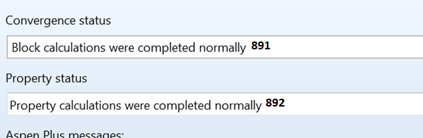

|  |  |  |  |
| --- | --- | --- | --- |
| **Flash2 Outputs Page 5: Status** | | | |
| **Function description** | **Function name** | **Path in Aspen** | **Function number** |
| Convergence status: | BLK_FLASH2_Get_ConvergenceStatus | Output.BLKSTAT.Value = 0 | 891 |
| Convergence Message: | BLK_FLASH2_Get_ConvergenceMessage | Output.BLKMSG.Value | 892 |
| Property status: | BLK_FLASH2_Get_PropertyStatus | Output.PROPSTAT.Value = 0 | 893 |

# DSTWU Input

## Specification PAGE 1:

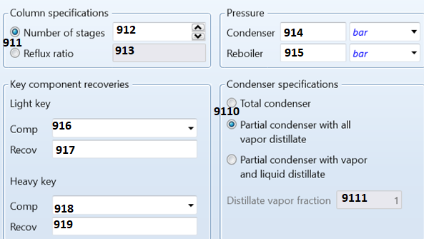

|  |  |  |  |  |
| --- | --- | --- | --- | --- |
| **Function description** | **Function name** | **Variable path** | **Function number** | **Extra Inputs** |
| Specification Option: | BLK_DSTWU_Set_  StageRefluxOption | Input.OPT_NTRR | 911 | 1. NSTAGE 2. RR |
| **If you chose NSTAGE:** | | | | |
| Number of Stages | BLK_DSTWU_Set_  NumberOfStages | Input.NSTAGE | 912 |  |
| **If you chose RR:** | | | | |
| Reboiler ratio | BLK_DSTWU_Set_  Refluxratio | Input.RR | 913 |  |
| Condenser Pressure: | BLK_DSTWU_Set_  CondenserPressure | Input.PTOP | 914 |  |
| Reboiler Pressure: | BLK_DSTWU_Set_  ReboilerPressure | Input.PBOT | 915 |  |
| Lightkey Component: | BLK_DSTWU_Set_  LightkeyComponent | Input.LIGHTKEY | 916 |  |
| Lightkey Recovery: | BLK_DSTWU_Set_  HeavykeyComponent | Input.RECOVL | 917 |  |
| Heavykey Component: | BLK_DSTWU_Set_  LightkeyRecovery | Input.HEAVYKEY | 918 |  |
| Heavykey Recovery: | BLK_DSTWU_Set_  HeavykeyRecovery | Input.RECOVH | 919 |  |
| Condenser specification: | BLK_DSTWU_Set_  CondenserOption | Input.OPT_RDV | 9110 | 1. LIQUID 2. VAPOR 3. VAPLIQ |
| **If VAPLIQ was chosen:** | | | | |
| Distillate vapor fraction: | BLK_DSTWU_Set_  VAPLIQ_  DestillVaporFraction | Input.RDV | 9111 |  |

## Calculation Options PAGE 2:

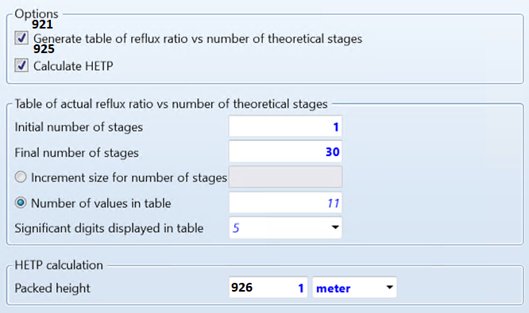

|  |  |  |  |  |
| --- | --- | --- | --- | --- |
| **Function description** | **Function name** | **Variable path** | **Function number** | **Extra Inputs** |
| Generate Table of reflux Option | BLK_DSTWU_Set_  GenerateTableOption | Input.PLOT. | 921 | 1. YES 2. NO |
| **If YES was chosen:** | | | | |
| First stage for calculation: | BLK_DSTWU_Set_  GenerateTable_FirstStage | Input.LOWER | 922 |  |
| Last stage for calculation: | BLK_DSTWU_Set_  GenerateTable_LastStage | Input.UPPER | 923 |  |
| Number of Stages in calculation: | BLK_DSTWU_Set_  GenerateTable_StageNumber | Input.NPOINT | 924 |  |
| Calculate HETP Option | BLK_DSTWU_Set_  CalculateHeightequivalent  HETP_Option | Input.OPT_CALHETP | 925 | 1. YES 2. NO |
| **If YES was chosen:** | | | | |
| Packed Height: | BLK_DSTWU_Set_  CalculateHeightequivalent  HETP_PackedHeight | Input.PACK_HEIGHT | 926 |  |

## Convergence PAGE 3:

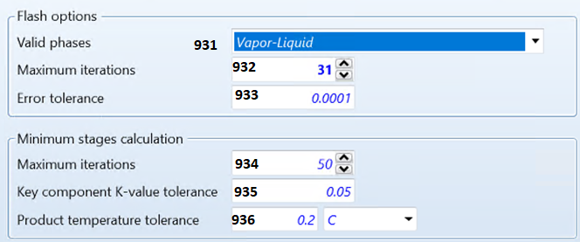

|  |  |  |  |  |
| --- | --- | --- | --- | --- |
| **Function description** | **Function name** | **Variable path** | **Function number** | **Extra Inputs** |
| Free water option as included in phase definition: | BLK_DSTWU_Set_  FreewaterOption | Input.BLKOPFREWAT | 931 | 1. YES 2. NO 3. DIRTY |
| Max number of Flash iterations | BLK_DSTWU_Set_  MaxNumber  FlashIterations | Input.FLASH_MAXIT | 932 |  |
| Flash convergence tolerance | BLK_DSTWU_Set_  FlashConvergence  Tolerance | Input.FLASH_TOL | 933 |  |
| Max number of min. Stages calculation: | BLK_DSTWU_Set_  MaxNumber  MinStageIterations | Input.MAXIT | 934 |  |
| Tolerance on K value for minimum stages: | BLK_DSTWU_Set_  KvalueTolerance | Input.K_TOL  Input.TEMP_TOL | 935 |  |
| Tolerance on product temperature: | BLK_DSTWU_Set_  ProductTemp  Tolerance | Input.TEMP_TOL | 936 |  |

# DSTWU OUTPUTS:

## Summary PAGE 1:

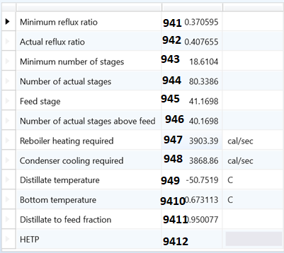

|  |  |  |  |
| --- | --- | --- | --- |
| **DSTWU Outputs Page 1: Summary** | | | |
| **Function description** | **Function name** | **Path in Aspen** | **Function number** |
| Minimum reflux ratio: | BLK_DSTWU_Get_MinimumRefluxRatio | Output.MIN_REFLUX.Value | 941 |
| Actual reflux ratio: | BLK_DSTWU_Get_ActualRefluxRatio | Output.ACT_REFLUX.Value | 942 |
| Minimum number of stages: | BLK_DSTWU_Get_MinimumNStage | Output.MIN_STAGES.Value | 943 |
| Actual number of stages: | BLK_DSTWU_Get_ActualNStage | Output.ACT_STAGES.Value | 944 |
| Actual number of stages above feed: | BLK_DSTWU_Get_ActualNumber  OfStagesAboveFeed | Output.FEED_LOCATN.Value | 945 |
| Feed stage: | BLK_DSTWU_Get_FeedStage | Output.FEED_LOCATN.Value | 946 |
| Reboiler heating required: | BLK_DSTWU_Get_ReboilerHeatingRequired | Output.RECT_STAGE.Value | 947 |
| Condenser cooling required: | BLK_DSTWU_Get_CondenserCoolingRequired | Output.COND_DUTY.Value | 948 |
| Destillate temperature: | BLK_DSTWU_Get_DestillateTemperature | Output.DISTIL_TEMP.Value | 949 |
| Bottom temperature: | BLK_DSTWU_Get_BottomTemperature | Output.BOTTOM_TEMP.Value | 9410 |
| Destillate to feed fraction: | BLK_DSTWU_Get_DestillateFeedFraction | Output.DIST_VS_FEED.Value | 9411 |
| HETP: | BLK_DSTWU_Get_HETP | Output.HETP.Value | 9412 |

## Balance PAGE 2:

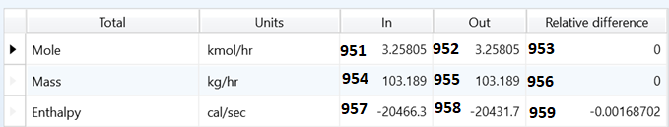

|  |  |  |  |
| --- | --- | --- | --- |
| **DSTWU Outputs Page 2: Balance** | | | |
| **Function description** | **Function name** | **Path in Aspen** | **Function number** |
| Mole Balance: IN | BLK_DSTWU_Get_MoleFlowBalanceIN() | Output.BAL_MOLI_TFL.Value | 951 |
| Mole Balance: OUT | BLK_ DSTWU_Get_  MoleFlowBalanceOUT() | Output.BAL_MOLO_TFL.Value | 952 |
| Mole Balance: Relative difference | BLK_ DSTWU_Get_  MoleFlowBalanceRelDifference() | Output.BAL_MOLR_TFL.Value | 953 |
| Mass Balance: IN | BLK_ DSTWU_Get_  MassFlowBalanceIN() | Output.BAL_MASI_TFL.Value | 954 |
| Mass Balance: OUT | BLK_ DSTWU_Get_  MassFlowBalanceOUT() | Output.BAL_MASO_TFL.Value | 955 |
| Mass Balance: Relative difference | BLK_ DSTWU_Get_  MassFlowBalanceRelDifference() | Output.BAL_MASR_TFL.Value | 956 |
| Enthalpy: IN | BLK_ DSTWU_Get_EnthalpyBalanceIN() | Output.TOT_ENTH_ABS.Value | 957 |
| Enthalpy: OUT | BLK_DSTWU_Get_EnthalpyBalanceOUT() | Output.BAL_ENTH_OUT.Value | 958 |
| Enthalpy: Relative difference | BLK_ DSTWU_Get_  EnthalpyBalanceRelDifference() | Output.TOT_ENTH_REL.Value | 959 |

## Reflux ratio profile PAGE 3:

The reflux profile is defined by the inputs: They are not sorted by the numbering of the values but rather by the Stage number. This makes extracting the data more complicated and it is necessary to loop through all the “Stagenumbers” and then extract the values afterwards to assign them together.

“Blockname”.Output.RR_Out.”Stagenumber”.Value

|  |  |  |  |
| --- | --- | --- | --- |
| **Function description** | **Function name** | **Path in Aspen** | **Function number** |
| Reflux ratio profile: | BLK_DSTWU_Get_RefluxRatioProfile | Output.RR_Out.”Stagenumber”.Value | 961 |

Careful! This one return two lists where one contains the stage numbers and the second one contains the reflux ratio at each of the stages.

## 21.4. Status PAGE 4:

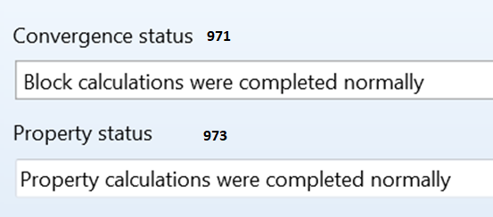

|  |  |  |  |
| --- | --- | --- | --- |
| **DSTWU Outputs Page 4: Status** | | | |
| **Function description** | **Function name** | **Path in Aspen** | **Function number** |
| Convergence status: | BLK_DSTWU_Get_ConvergenceStatus | Output.BLKSTAT.Value = 0 | 971 |
| Convergence Message: | BLK_DSTWU_Get_ConvergenceMessage | Output.BLKMSG.Value | 972 |
| Property status: | BLK_DSTWU_Get_PropertyStatus | Output.PROPSTAT.Value = 0 | 973 |

# FSPLITTER Input

## Specification PAGE 1:

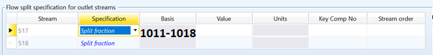

|  |  |  |  |  |
| --- | --- | --- | --- | --- |
| **Function description** | **Function name** | **Variable path** | **Function number** | **Extra Inputs/Options** |
| Split fraction: | BLK_SPLITTER_Set  _By_Flow | Input.FRAC.  ”Streamname”.Value | 1011 |  |
| Flow: | BLK_SPLITTER_Set  _By_Flow | Input.BASIS_FLOW.  ”Streamname.Value” | 1012 |  |
| Actual volume flow: | BLK_SPLITTER_Set  _By_ActualVolumeFlow | Input.VOL_FLOW.  ”Streamname”.Value | 1013 |  |
| Limit flow: | BLK_SPLITTER_Set  _By_LimitFlow | Input.BASIS_LIMIT.  ”Streamname”.Value | 1014 |  |
| Volume limit flow: | BLK_SPLITTER_Set  _By_VolumeLimitFlow | Input.VOL_LIMIT.  ”Streamname”.Value | 1015 |  |
| Cum limit flow: | BLK_SPLITTER_Set  _By_CumLimitFlow | Input.BASIS_C_LIM.  ”Streamname”.Value | 1016 |  |
| Cum volume limit flow: | BLK_SPLITTER_Set  _By_CumVolumeLimitFlow | Input.VOL_C_LIM.  ”Streamname”.Value | 1017 |  |
| Residual fraction: | BLK_SPLITTER_Set  _By_ResidualFraction | Input.R_FRAC.  ”Streamname”.Value | 1018 |  |

## Flash Options PAGE 2:

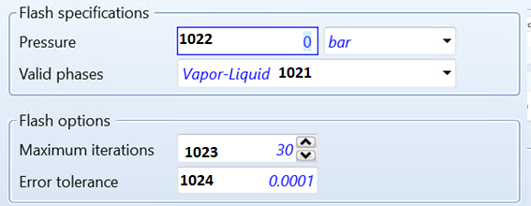

|  |  |  |  |  |
| --- | --- | --- | --- | --- |
| **Function description** | **Function name** | **Variable path** | **Function number** | **Extra Inputs** |
| Phase number and Phase | BLK_SPLITTER_  Set_Phases | Input.NPHASE1.Value  Input.PHASE1.Value | 1021 | = 1, 2, 3  = “V”, “L”, “S” |
| Estimated Pressure | BLK_SPLITTER_  Set_Pressure | Input.P_EST.Value | 1022 |  |
| Maximum iterations | BLK_SPLITTER_Set_  MaximumIteration | Input.MAXIT.Value | 1023 |  |
| Error tolerance | BLK_SPLITTER_Set_  ErrorTolerance | Input.TOL.Value | 1024 |  |

## Key Components PAGE 3

missing

# FSPLITTER Output

## Summary PAGE 1:

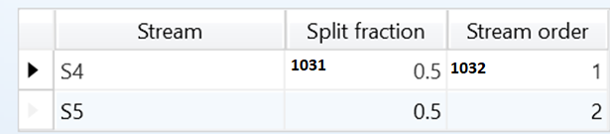

|  |  |  |  |  |
| --- | --- | --- | --- | --- |
| **FSplit Outputs Page 1: Summary** | | | |  |
| **Function description** | **Function name** | **Path in Aspen** | **Function number** | **Input** |
| Splitfraction per Stream | BLK_FSPLITTER_Get  _SplitFraction | Output.STREMFRAC.  Streamname.Value | 1031 | Stream name |
| Stream order per Stream | BLK_FSPLITTER_Get  _StreamOrder | Output.STREAM_ORDER.  Streamname.Value | 1032 | Stream name |

## Balances PAGE 2:

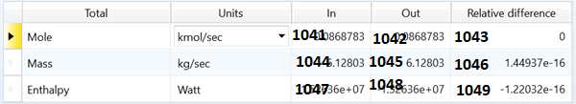

|  |  |  |  |
| --- | --- | --- | --- |
| **FSplit Outputs Page 2: Balance** | | | |
| **Function description** | **Function name** | **Path in Aspen** | **Function number** |
| Mole Balance: IN | BLK_FSPLITTER_Get_  MoleFlowBalanceIN | Output.BAL_MOLI_TFL.Value | 1041 |
| Mole Balance: OUT | BLK_FSPLITTER_Get_  MoleFlowBalanceOUT | Output.BAL_MOLO_TFL.Value | 1042 |
| Mole Balance: Relative difference | BLK_FSPLITTER_Get_  MoleFlowBalanceRelDifference | Output.BAL_MOLR_TFL.Value | 1043 |
| Mass Balance: IN | BLK_FSPLITTER_Get_  MassFlowBalanceIN | Output.BAL_MASI_TFL.Value | 1044 |
| Mass Balance: OUT | BLK_FSPLITTER_Get_  MassFlowBalanceOUT | Output.BAL_MASO_TFL.Value | 1045 |
| Mass Balance: Relative difference | BLK_FSPLITTER_Get_  MassFlowBalanceRelDifference | Output.BAL_MASR_TFL.Value | 1046 |
| Enthalpy: IN | BLK_FSPLITTER_Get_  EnthalpyBalanceIN | Output.TOT_ENTH_ABS.Value | 1047 |
| Enthalpy: OUT | BLK_FSPLITTER_Get_  EnthalpyBalanceOUT | Output.BAL_ENTH_OUT.Value | 1048 |
| Enthalpy: Relative difference | BLK_FSPLITTER_Get_  EnthalpyBalanceRelDifference | Output.TOT_ENTH_REL.Value | 1049 |

## Status PAGE 3:

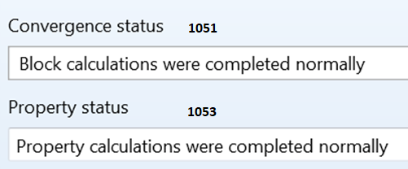

|  |  |  |  |
| --- | --- | --- | --- |
| **FSplit Outputs Page 3: Status** | | | |
| **Function description** | **Function name** | **Path in Aspen** | **Function number** |
| Convergence status: | BLK_FSPLITTER_Get_  ConvergenceStatus | Output.BLKSTAT.Value = 0 | 1051 |
| Convergence Message: | BLK_FSPLITTER_Get_  ConvergenceMessage | Output.BLKMSG.Value | 1052 |
| Property status: | BLK_FSPLITTER_Get_  PropertyStatus | Output.PROPSTAT.Value = 0 | 1053 |

# STREAM INPUT

## Specifications PAGE 1

For all streams the general Path towards the variables which are below is:

Data.Streams.”Streamname”.Input.

This will be ignored in the next few ones because it simplifies the pathway and heightens the readability.

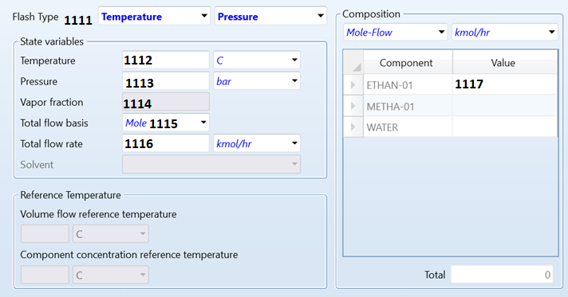

|  |  |  |  |  |
| --- | --- | --- | --- | --- |
| **Function description** | **Function name** | **Variable path** | **Function number** | **Extra Inputs** |
| Flash type Option: | STRM_Set_FlashTypeOption | Input.MIXED_SPEC.  MIXED.Value | 1111 | 1. TP 2. TV 3. PV |
| Temperature: | STRM_Set_Temperature | Input.TEMP.Value | 1112 |  |
| Pressure: | STRM_Set_Pressure | Input.PRES.Value | 1113 |  |
| Vapor fraction: | STRM_Set_VaporFraction | Input.VFRAC | 1114 |  |
| Total flow basis: | STRM_Set_TotalFlowRate | Input.FLOWBASE.  MIXED.Value | 1115 | A) MASS  B ) MOLE  C ) STDVOL  D ) VOLUME |
| Total flow rate: | STRM_Set_TotalFlowBasis | Input.TOTFLOW.Value | 1116 |  |
| Composition: (specified for each compound) | STRM_Set_ComponentFlowRate | Input.FLOW.MIXED.  ”Compoundname”  .Value | 1117 |  |

For all streams the general path towards the variables which are below is:

Data.Streams.”Streamname”.Input.

This will be ignored in the next few ones because it simplifies the pathway and heightens the readability.

## CI Solid PAGE 2 MISSING

Missing

## NC Solid PAGE 3 MISSIGN

missing

## Flash Options PAGE 4

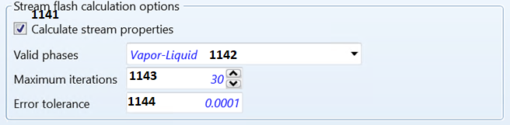

|  |  |  |  |  |
| --- | --- | --- | --- | --- |
| **Function description** | **Function name** | **Variable path** | **Function number** | **Extra Inputs** |
| Calculate flash Calculation Option: | STRM_Set_  CalculateStream  PropertiesOption | Input.FL_OPTION.  MIXED.Value | 1141 | 1. “NOFLASH” 2. “” |
| Valid phases | STRM_Set_Phases | Input.PHASE.MIXED.Value  Input.NPHASE.MIXED.Value | 1142 |  |
| Max number of Flash iterations | STRM_Set_  MaximumIteration | Input.MAXIT.MIXED | 1143 |  |
| Flash convergence tolerance: | STRM_Set_  ErrorTolerance | Input.TOL.MIXED | 1144 |  |

## EO Options PAGE 5

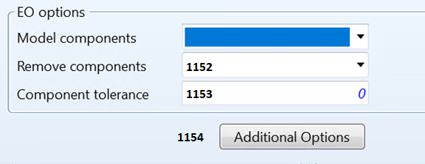

|  |  |  |  |  |
| --- | --- | --- | --- | --- |
| **Function description** | **Function name** | **Variable path** | **Function number** | **Extra Inputs** |
| Model component: | **Not implemented** | | | |
| Remove component: | STRM_Set_  RemoveComponentOption | Input.AUTO_COMPS  .Value | 1152 | A ) ALWAYS  B ) IF-NO-COMPS  C ) NEVER |
| Component tolerance: | STRM_Set_  ComponentTolerance | Input.AUTO_COMPS_T  .Value | 1153 |  |
| Choosing Additional Options: | STRM_Set_  ChooseAdditionalOptions | Input.EO_COMPS  .Value | 1154 |  |

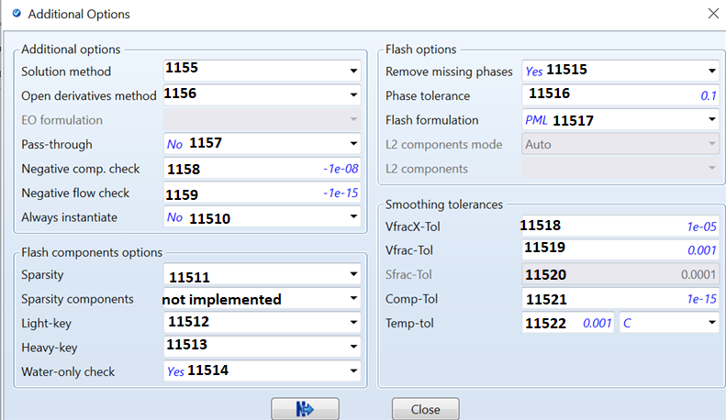

|  |  |  |  |  |
| --- | --- | --- | --- | --- |
| **Function description** | **Function name** | **Variable path** | **Function number** | **Extra Inputs** |
| Solution method: | STRM_Set_  AddOptSolution  Method | Input.SOL  _METHOD.Value | 1155 | A ) OPEN-PERT-IN  B ) OPEN-PERT-WA  C ) OPEN-NOPERT  D ) PERTUBATION  E ) DO-NOT-CREAT |
| Open derivatives method: | STRM_Set_  AddOptOpen  DerivationMethod | Input.DERIV  _METHOD.Value | 1156 | A ) ANALYTICAL  B ) NUMERICAL  C ) UPDATE-ANALY  D ) UPDATE-NUMER |
| Pass-through: | STRM_Set_  AddOptPassThrough | Input.PASS_  THROUGH.Value | 1157 | 1. **YES** 2. **NO** |
| Negative comp. check: | STRM_Set_  AddOptNegative  ComponentCheckTol | Input.NEG_  COMP_CHK.Value | 1158 |  |
| Negative flow check: | STRM_Set_  AddOptNegative  FlowCheckTol | Input.NEG_  FLOW_CHK.Value | 1159 |  |
| Always Instantiate: | STRM_Set_  AddOptAlways  Instantiate | Input.ALWAYS_  INST.Value | 11510 |  |
| **Flash Component Option:** | | | | |
| Sparcity: | STRM_Set_  AddOptSparcity | Input.SPARSITY  .Value | 11511 | A ) COMP-INDEP  B ) FULL  C ) WATER-SOLU |
| Sparcity component | Not implemented | | | |
| Lightkey: | STRM_Set_  AddOptLightkey | Input.EO_LIGHT  _KEY.Value | 11512 |  |
| Heavykey: | STRM_Set_  AddOptHeavykey | Input.EO_HEAVY  _KEY.Value | 11513 |  |
| Water only check: | STRM_Set_  AddOptWater  OnlyCheck | Input.CHECK_FREE  _W.Value | 11514 |  |
| **Flash Options** | | | | |
| Remove missing phase: | STRM_Set_  AddOptRemove  MissingPhase | Input.AUTO_PHASE  .Value | 11515 |  |
| Phase tolerance: | STRM_Set_  AddOptPhase  Tolerance | Input.AUTO_PHASE  _T.Value | 11516 |  |
| Flash formulation: | STRM_Set_  AddOptFlash  Formulation | Input.FLASH_FORM  .Value | 11517 | A ) PML  B ) SMOOTHING |
| **Smoothing tolerances:** | | | | |
| VfracX-Tolerance | STRM_Set_  AddOptSmoothing  VfracXTol | Input.VFRACX_TOL  .Value | 11518 |  |
| Vfrac-Tolerance | STRM_Set_  AddOptSmoothing  VfracTol | Input.VFRAC_TOL  .Value | 11519 |  |
| Sfrac-Tolerance | STRM_Set_  AddOptSmoothing  SfracTol | Input.SFRAC_TOL  .Value | 11520 |  |
| Composition Tolerance | STRM_Set_  AddOptSmoothing  CompositionTol | Input.COMP_TOL  .Value | 11521 |  |
| Temperature Tolerance | STRM_Set_AddOpt  Smoothing  TemperatureTol | Input.EO_TEMP_  TOL.Value | 11522 |  |

## Costing PAGE 6



|  |  |  |  |  |
| --- | --- | --- | --- | --- |
| **Function description** | **Function name** | **Variable path** | **Function number** | **Extra Inputs** |
| Price per Unit: | STRM_Set_PricePerUnit | Input.PRICE.Value | 1161 |  |
| Change Unit: | STRM_Set_ChangePriceUnit | Input.PRICE.**Basis** | 1162 |  |

# STREAM OUTPUTS:

|  |  |  |  |  |
| --- | --- | --- | --- | --- |
| **Function description** | **Function name** | **Path in Aspen** | **Function number** | **Inputs** |
| Stream source: | STRM_Get_Source() | STRM.Streamname.Output  .STR_MAIN.SOURCE.Value | 1171 | Stream name |
| Stream destination: | STRM_Get_Destination() | STRM.Streamname.Output  .STR_MAIN.DESTINATION.Value | 1172 | Stream name |
| Stream Phase: | STRM_Get_Phase() | STRM.Streamname.Output  .STR_MAIN.COMPTYPE.Value | 1173 | Stream name |
| Property set: | STRM_Get_PropertySet() | STRM.Streamname.Output  .STR_MAIN.PPOPSET.Value | 1174 | Stream name |
| total mol flow per compound | STRM_Get_  MoleFlowPerCompound() | STRM.Streamname.Output  .STR_MAIN.MOLEFLOW  .MIXED.Compoundname.Value | 1175 | Stream name,  Compound name |
| total mass flow per compound | STRM_Get_  MassFlowPerCompound() | STRM.Streamname.Output  .STR_MAIN.MASSFLOW  .MIXED.Compoundname.Value | 1176 | Stream name,  Compound name |
| total volume flow per compound | STRM_Get_VolumeFlow() | STRM.Streamname.Output  .STR_MAIN.VOLFLMX  .MIXED.Value | 1177 | Stream name |
| Mole frac by Compound: | STRM_Get_  MoleFracPerCompound() | STRM.Streamname.Output  .MOLEFRAC.MIXED  .Compoundname.Value | 1178 | Stream name,  Compound name |
| Mass frac by Compound: | STRM_Get_  MassFracPerCompound() | STRM.Streamname.Output  .MASSFRAC.MIXED  .Compoundname.Value | 1179 | Stream name,  Compound name |
| Temperature: | STRM_Get_Temperature() | STRM.Streamname.Output  .STR_MAIN.TEMP.MIXED.Value | 11710 | Stream name |
| Pressure: | STRM_Get_Pressure() | STRM.Streamname.Output  .STR_MAIN.PRES.MIXED.Value | 11711 | Stream name |
| Liquid concentration: | STRM_Get_Liquid  ConcentrationPerCompound() | STRM.Streamname.Output  .X.Compoundname.Value | 11712 | Stream name |
| Vapor concentration: | STRM_Get_Vapor  ConcentrationPerCompound() | STRM.Streamname.Output  .Y.Compoundname.Value | 11713 | Stream name |
| Vapor fraction: | STRM_Get_VaporFraction() | STRM.Streamname.Output  .STR_MAIN.VFRAC.MIXED.Value | 11714 | Stream name |
| Liquid fraction | STRM_Get_LiquidFraction() | STRM.Streamname.Output  .STR_MAIN.LFRAC.MIXED.Value | 11715 | Stream name |
| Solid fraction: | STRM_Get_SolidFraction() | STRM.Streamname.Output  .STR_MAIN.SFRAC.MIXED.Value | 11716 | Stream name |